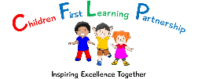

**COVID-19 Additional Behaviour Policy**

**May 2020**

**Handwashing is compulsory….**

* On arrival
* After toileting
* After each outdoor play
* Before/After Eating
* Before leaving

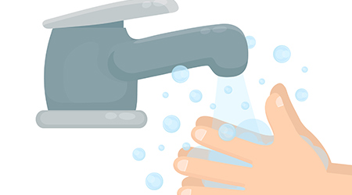

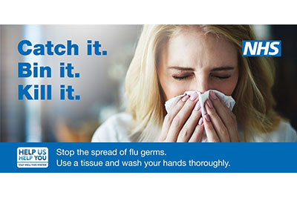

**Tissues**

* Children are encouraged to use tissues to catch germs when sneezing and coughing and bin the tissues. Then wash hands.

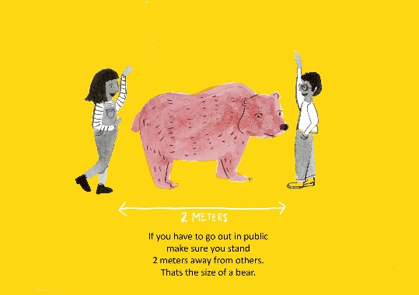

**2 metre rule**

* Staff and children must adhere to the 2 metre rule at all times both indoors and outdoors

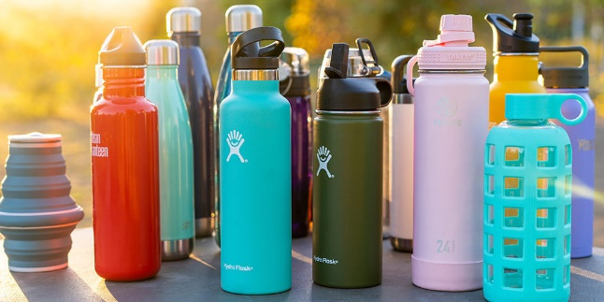

**Water bottles**

* Water bottles to be taken home to be washed daily.

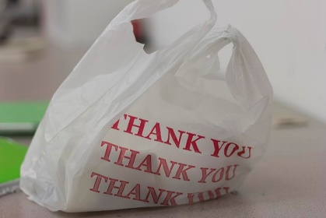

**No lunchboxes or school bags please**

* Universal free school meals are available
* However, if you want to provide your own lunch then please send in a disposable bag

**Clothing**

* Children to attend school in clean clothes every day
* Uniform is NOT required
* Children to bring a coat each day

