https://www.calameo.com/read/000777721945cfe5bb9cc?authid=Xu9pcOzU3TQx
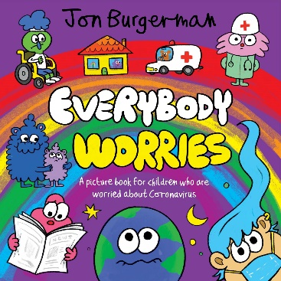 | Everybody Worries Epdf  A picture book for children who are worried about Coronavirus  www.calameo.com

