General Websites
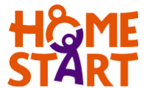
https://www.home-start.org.uk/special-needs
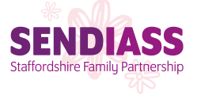
https://www.staffs-iass.org/home.aspx

http://www.ace-ed.org.uk/

https://www.staffordshireconnects.info/kb5/staffordshire/directory/home.page
https://www.family-action.org.uk/family-monsters/support/supporting-children-with-a-learning-disabilities/
https://www.familylives.org.uk/how-we-can-help/parentchannel-tv/

Where can I find help if my child has….
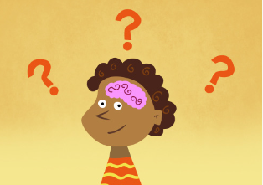
Dyslexia

https://www.nhs.uk/conditions/dyslexia/living-with/
https://www.bdadyslexia.org.uk/
https://www.dyslexia.uk.net/
https://www.nessy.com/uk/parents/dyslexia-information/
http://madebydyslexia.org/

http://www.thedyslexia-spldtrust.org.uk/

Where can I find help if my child has….

Dyspraxia
https://www.nhs.uk/conditions/developmental-coordination-disorder-dyspraxia/
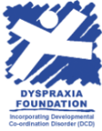

https://dyspraxiafoundation.org.uk/dyspraxia-children/symptoms/
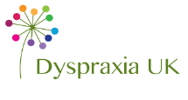

https://www.dyspraxiauk.com/primaryagechildren.php
https://www.nrshealthcare.co.uk/articles/condition/dyspraxia

Where can I find help if my child has….

Dyscalculia
http://dyscalculia.me.uk/resources-for-parents.html

https://www.thebraincharity.org.uk/how-we-can-help/practical-help/information-advice/a-z-of-conditions/35-d/637-dyscalculia

https://mindsofwonder.com/2018/02/08/tips-to-help-your-child-with-dyscalculia/
https://www.bdadyslexia.org.uk/dyslexia/neurodiversity-and-co-occurring-differences/dyscalculia-and-maths-difficulties

Where can I find help if my child has….

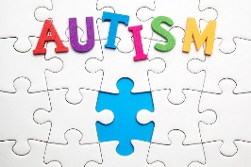
Autism

https://www.nhs.uk/conditions/autism/support/

https://www.childautism.org.uk/

https://www.autism.org.uk/

https://www.ambitiousaboutautism.org.uk/
https://www.helpguide.org/articles/autism-learning-disabilities/helping-your-child-with-autism-thrive.htm

https://www.autismlinks.co.uk/support-groups

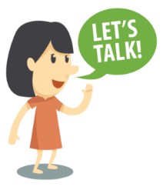
Where can I find help if my child has….

Speech and Language Difficulties
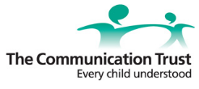
https://www.thecommunicationtrust.org.uk/resources/resources/resources-for-parents/
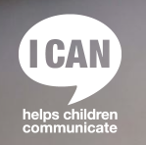

https://ican.org.uk/i-cans-talking-point/parents/
https://www.nhs.uk/conditions/social-care-and-support-guide/practical-tips-if-you-care-for-someone/how-to-care-for-someone-with-communication-difficulties/
https://www.bbc.co.uk/cbeebies/grownups/speech-and-language-difficulties

https://kidshealth.org/en/parents/comm-4-to-5.html

https://www.afasic.org.uk/resources/links/speech-and-language-help/

https://www.mpft.nhs.uk/services/speech-language-therapy-services-children

Where can I find help if my child has….

Behaviour or Mental Health Difficulties

Visyon is a charity that supports the emotional health of children, young people and their families in the Cheshire and Staffordshire moorlands areas.
https://www.visyon.org.uk/
This is the UK's leading charity committed to improving the emotional well-being and mental health of children and young people.
https://youngminds.org.uk/find-help/for-parents/parents-guide-to-support-a-z/parents-guide-to-support-challenging-behaviour-in-children/

Protect and support children and young people, provide practical and emotional care and support, ensure their voices are heard, and campaign to bring lasting improvements to their lives.
https://www.actionforchildren.org.uk/support-for-parents/
Beat is a website dedicated to Eating Disorders. https://www.beateatingdisorders.org.uk/
An online learning and advice resource for anyone interested in, or concerned about, the mental health of children and teenagers. https://www.minded.org.uk/
A counselling service for children and young people up to their 19th birthday in the UK provided by the NSPCC https://www.childline.org.uk/
Providing information & support to families when a child is bereaved.
https://www.childbereavementuk.org/
Offers support and information for young people experiencing bullying.
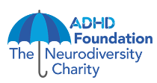
https://www.kidscape.org.uk/
Support and information about ADHD
https://www.adhdfoundation.org.uk/
Where can I find help if my child has….

Sensory Difficulties
Hearing Impairment
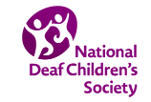
https://www.ndcs.org.uk/information-and-support/

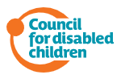
This is an Early Support information resources on deafness and hearing loss and is for parent carers with children up to the age of 25 who are deaf.
https://councilfordisabledchildren.org.uk/help-resources/resources/early-support-information-deafness-and-hearing-loss
The Hearing Impairment Team supports children and young people with a hearing impairment at home, in early years settings, mainstream and special schools aged 0-25
https://www.staffordshireconnects.info/kb5/staffordshire/directory/service.page?id=zcu7s5y1rzo

Providing help, support, advice and information for people with hearing loss and their families and friends.
https://www.supportstaffordshire.org.uk/organisation-directory/action-hearing-loss-aohl

Vision Impairment
The Vision Impairment Team supports children and young people aged 0-25 years with a vision impairment at home, in early years settings, mainstream and special schools.
https://www.staffordshireconnects.info/kb5/staffordshire/directory/service.page?id=y-2Vqpr9Lgw
VICTA is a national charity that provides support to children and young adults from 0 to 29 who are blind or partially sighted and their families.
https://www.victa.org.uk/

Provide a range of services in London and across England and Wales for blind and partially sighted children and young people, their families, and the professionals who work alongside them. https://www.rsbc.org.uk/what-we-do
Where can I find help if my child has….

Physical Difficulties

https://www.scope.org.uk/advice-and-support/support-groups-parents/
https://www.gov.uk/help-for-disabled-child

https://www.nhs.uk/conditions/social-care-and-support-guide/caring-for-children-and-young-people/how-to-care-for-children-with-complex-needs/
https://www.cerebralpalsy.org/information/acceptance/tips-for-parents

https://www.cerebralpalsyguide.com/community/parents-caregivers/

https://www.cdc.gov/ncbddd/spinabifida/infant.html
https://www.jiraffe.org.uk/working-with-children-with-physical-disabilities/

