OXHEY FIRST SCHOOL
A HAPPY PLACE TO LEARN AND GROW
Excellence, Teamwork, Equality, Respect
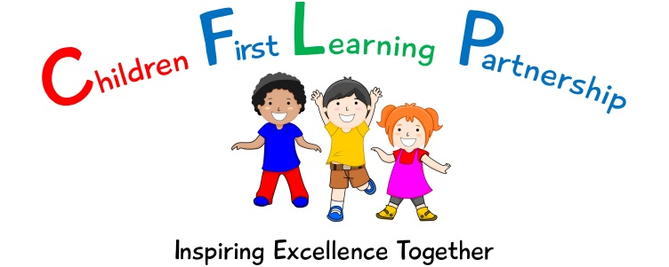
Oxhey First School
Pennine Way,
Biddulph
Staffordshire
ST8 7EB

Head teacher: Mrs L. Jukes
Telephone 01782 513000
E mail office@oxhey.staffs.sch.uk
www.oxheyfirstschool.com

Dear Parents/Carers

At Oxhey, we aim to promote the importance of happy, healthy lifestyles and mental health and emotional well-being are a central part of this. We have been working with external agencies, such as Trailblazers, as well as investing in activities and classroom practices across the MAT (Forest Schools, emotion boards, worry boxes, special assemblies, yoga etc) to ensure our children understand what mental health is and what to do if they feel emotionally unwell.

I am very pleased to write, therefore to inform you of a community-based project we are launching at Oxhey entitled ‘Happy Mind, Healthy Me!’ The project seeks to promote emotional and mental well-being in our children and their families by delivering a programme of events, designed to promote wellness, which they can participate in together.

We hope that staff, local businesses and invited members of the community will be willing to deliver sessions at Oxhey, (such as physical activities, gardening, painting, crafts, cookery, massage etc.) that families can sign-up to. We would also like to tap into the interests and expertise of our parents and offer the opportunity to run a workshop, with the support of staff.

To set the project into context, 13% of young people aged 5-19 meet clinical criteria for a mental health disorder and typically wait more than six months to receive care from a specialist. 10% of young people aged 8-15 experience a low sense of well-being. The NHS and Royal College of Psychiatrists report that mental ill health has associated costs of £105 billion each year. We hope that projects such as ‘Happy Mind, Healthy Me’ will begin to support and educate our young people and their families on how engaging in enjoyable activities can promote their self-esteem, alongside their physical, emotional and mental wellness, and reduce these concerning statistics.

If you have a particular interest you would like to share or a business you’d like to promote by running a workshop in school, please contact me via the office. Please keep an eye on the newsletter for details of further parent drop-ins with Trailblazers and a programme of Happy Mind Healthy Me events.

Many thanks for your support

Mrs L. Holt
SENCO/Inclusion Lead

