OXHEY FIRST SCHOOL
A HAPPY PLACE TO LEARN AND GROW
Excellence, Teamwork, Equality, Respect

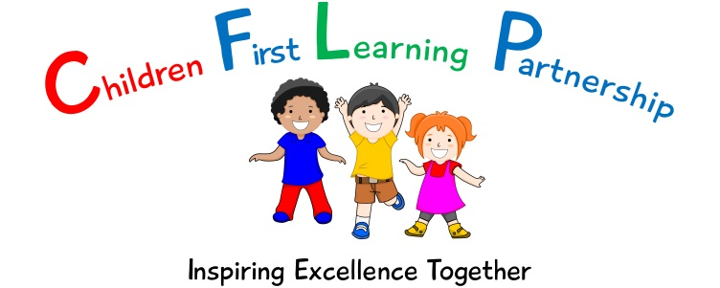

Oxhey First School
Pennine Way,
Biddulph
Staffordshire
ST8 7EB

Head teacher: Mrs L Jukes
Telephone 01782 513000
E mail office@oxhey.staffs.sch.uk
www.oxheyfirstschool.com

30.09.22
Dear Parents and Carers,

An exciting week is ahead for our pupils at Oxhey; the Book Fair is coming to our school! The Book Fair is visiting on the 6th October to the 12th October. A timetable for the event can be seen below:

Date and Time:  After School: 3:25pm - 4:15pm  Before School (Tuesday only) 8:30am - 9:15am | Location:
Thursday 6th October – 3:25pm-4:15pm | Nursery Room – enter through Main Office
Friday 7th October - 3:25pm-4:15pm | Nursery Room – enter through Main Office
Monday 10th October - 3:25pm-4:15pm | Nursery Room – enter through Main Office
Tuesday 11th October – 8:30am-9:15am | Nursery Room – enter through Main Office
Wednesday 12th October - 3:25pm-4:15pm | Nursery Room – enter through Main Office

The event will be a cashless event with the option to pay using a QR code or via a link that will be sent out through a text message. You can click on this link which will take you directly to a payment page. You will be then asked to put in your details and pay for the book or item that you wish to purchase. More information on payment can be found on the back page of this attached letter. The attached letter also highlights some of the books that can be purchased on the too.

We are very much looking forward to seeing you at the Book Fair. If you have any questions, please see your child’s class teacher.

Many thanks,

Miss Walker

