OXHEY FIRST SCHOOL
A HAPPY PLACE TO LEARN AND GROW
Excellence, Teamwork, Equality, Respect

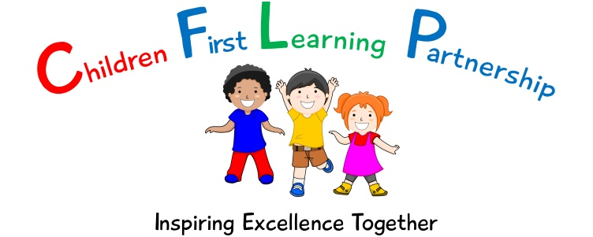

Oxhey First School
Pennine Way,
Biddulph
Staffordshire
ST8 7EB

Head teacher: Mrs L Jukes
Telephone 01782 513000
E mail office@oxhey.staffs.sch.uk
www.oxheyfirstschool.com

Macmillan Fundraising Event

Dear Parents and Carers,

Every year, Macmillan hold a charity fundraising event which encourages communities to come together and share some cake while raising much needed funds and awareness for a fantastic cause.
As a school, we feel this is something that we would like to continue to support and therefore we will be holding our own ‘in school’ event next Friday 30th September. The school council met this week to discuss ideas and have agreed that all children:
- Are invited to wear green/white/purple clothes or accessories to school.
- Can wear face paint or style their hair in the Macmillan colours.
- Will be able to enjoy a slice of cake in class.
The cakes will be provided by school, however, if you do not want your child to take part, or they have dietary needs, please let their class teacher know.

All we are asking is for a voluntary donation of £2.00 per child which can be made via our Just Giving link shown below. We will also text this out so you can have a direct link to the website to make a quick and easy donation.

https://www.justgiving.com/fundraising/oxhey-first-school3

Thank you for your continued support,

Yours sincerely,

Mrs Nevitt, The School Council and Oxhey Staff

