OXHEY FIRST SCHOOL
A HAPPY PLACE TO LEARN AND GROW
Excellence, Teamwork, Equality, Respect

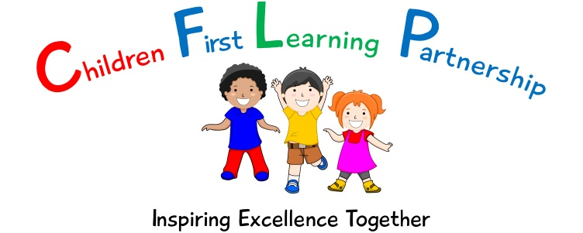
Oxhey First School
Pennine Way,
Biddulph
Staffordshire
ST8 7EB

Head teacher: Mrs L Jukes
Telephone 01782 513000
E mail office@oxhey.staffs.sch.uk
www.oxheyfirstschool.com

AUTUMN TERM CLUBS 2022

Dear Parents/Carers,

Please find overleaf the timetable for clubs that will be offered this term. Some of our clubs will be run by Little Athletes and Goal-coaching - these clubs are ‘parent pay’ and are booked directly with the company. They will also be on a first come first served basis.

To book a place with Little Athletes please ring 01782 825612.

To book a place on to the Goal Coaching, please go on to www.goalcoaching.co.uk. Click on ‘afterschool clubs’ and ‘Oxhey First School’.

Please complete the attached club reply slip and hand to your child’s class teacher by Monday 12th September 2022. Please do not apply for clubs that are invitation only or are not aimed at your child’s Key Stage. Once permission slips have been returned, we will text to confirm which club your child has been allocated a place in, unless of course it is an invitation only club. Please bear in mind that clubs also have limited places available. Places are allocated on a first come, first served basis.

If your child cannot attend their allocated club for any reason please inform the school office. School will contact parents if a club must be unavoidably cancelled. Children will be dismissed from clubs via the main entrance unless otherwise specified. Unless otherwise stated, clubs will start week beginning Monday 19th September and run until the end of the week beginning 28th November 2022.

I would like to thank staff for providing these additional opportunities for our children and our parents for supporting the clubs.

Mrs. Jones
PE/Clubs lead
Autumn TERM CLUBS 2022

I give permission for my child ___________________________________Class _______to take part in ______________________________________________________________________ (name of club).
Signed: __________________________________________ (Parent/Guardian)

