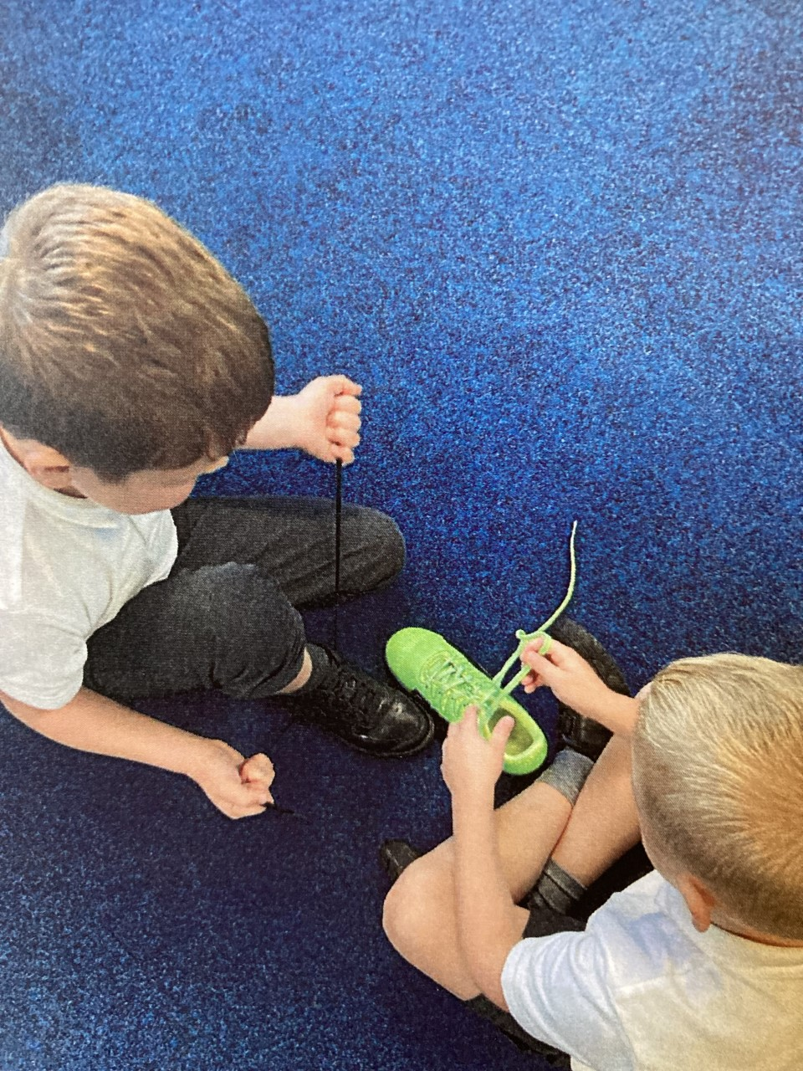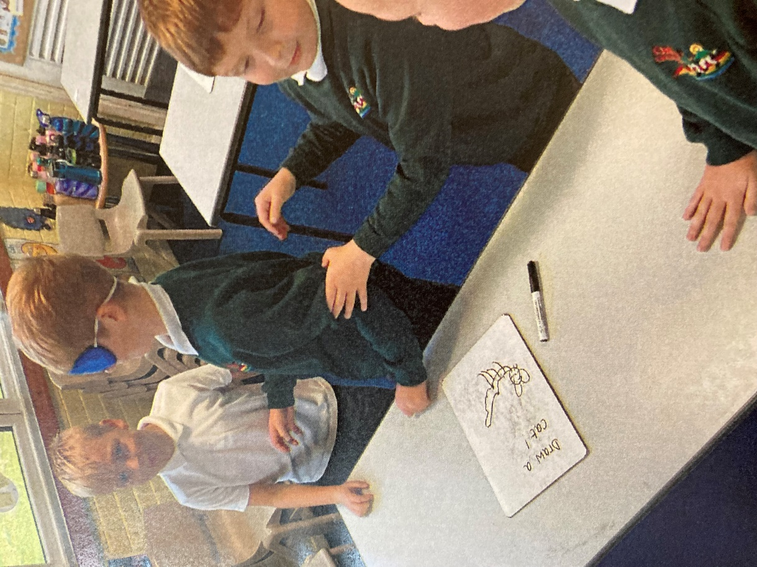

We tied shoelaces and used our newly practised communication skills during a guidance task, to teach and show others how to tie theirs!

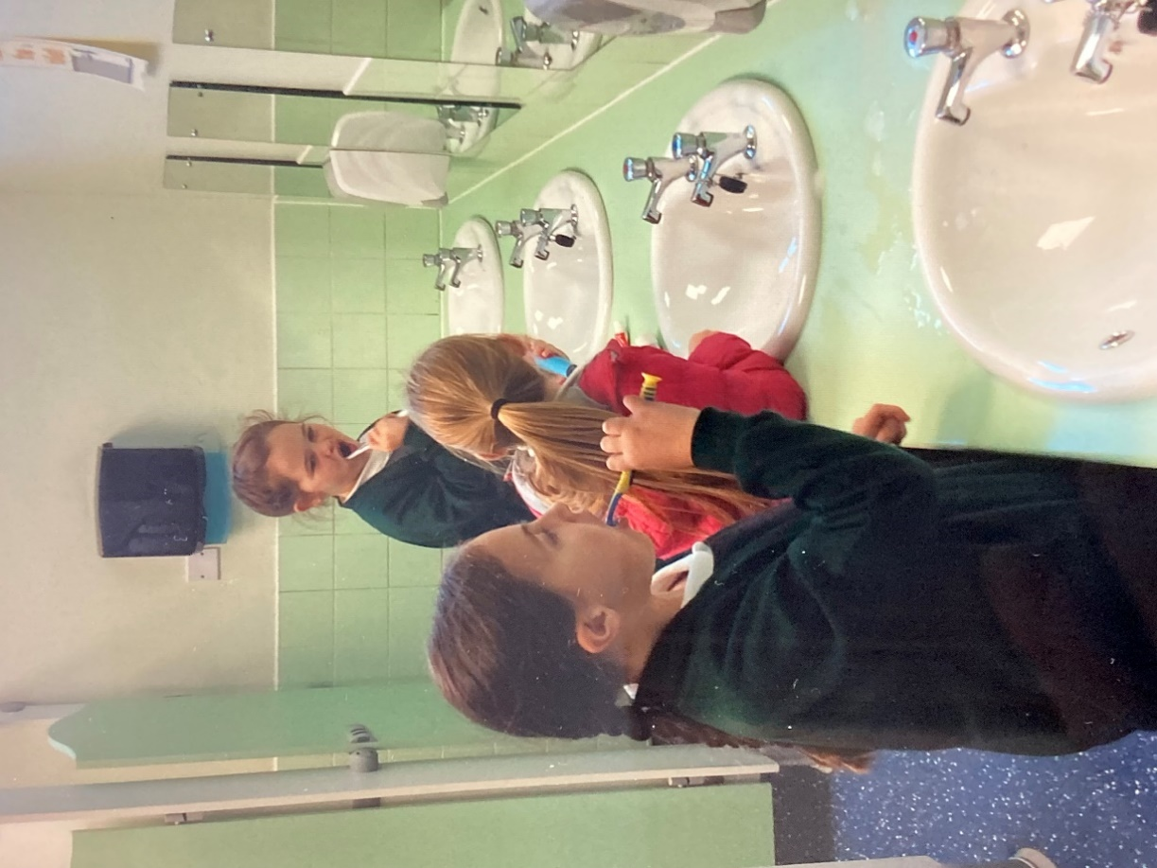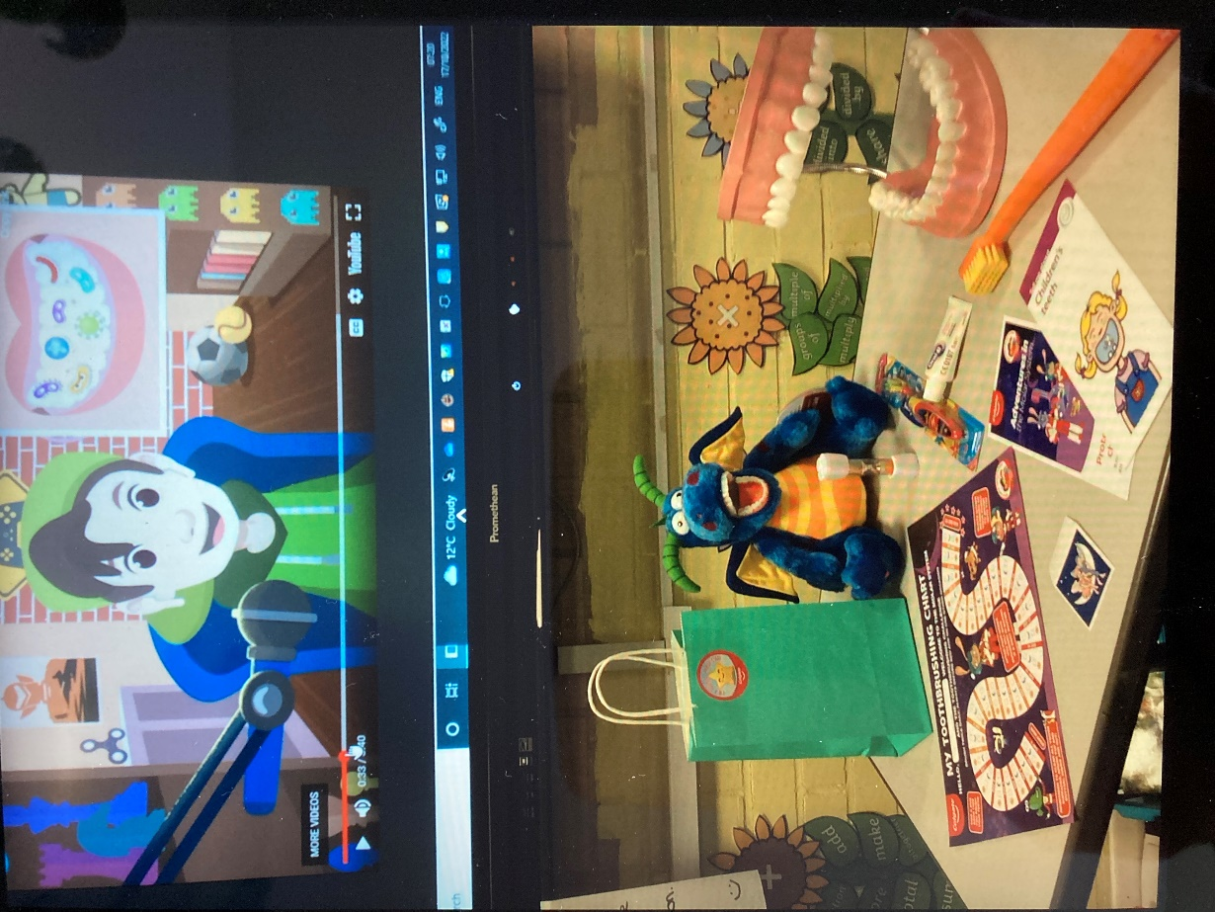
We discussed the importance of our personal hygiene.
We cleaned our teeth for the recommended two minutes and all took away
some ‘toothy’ treats!
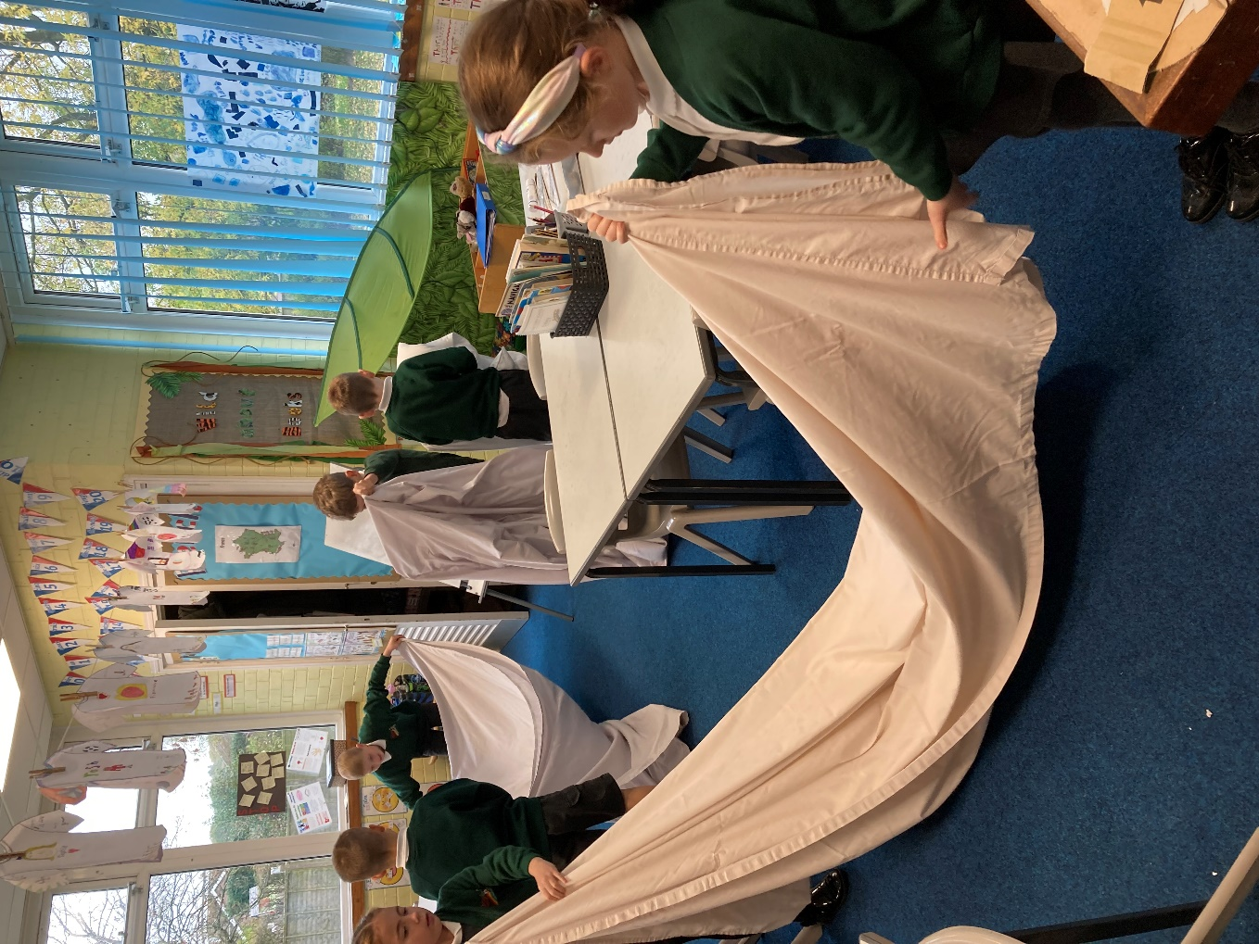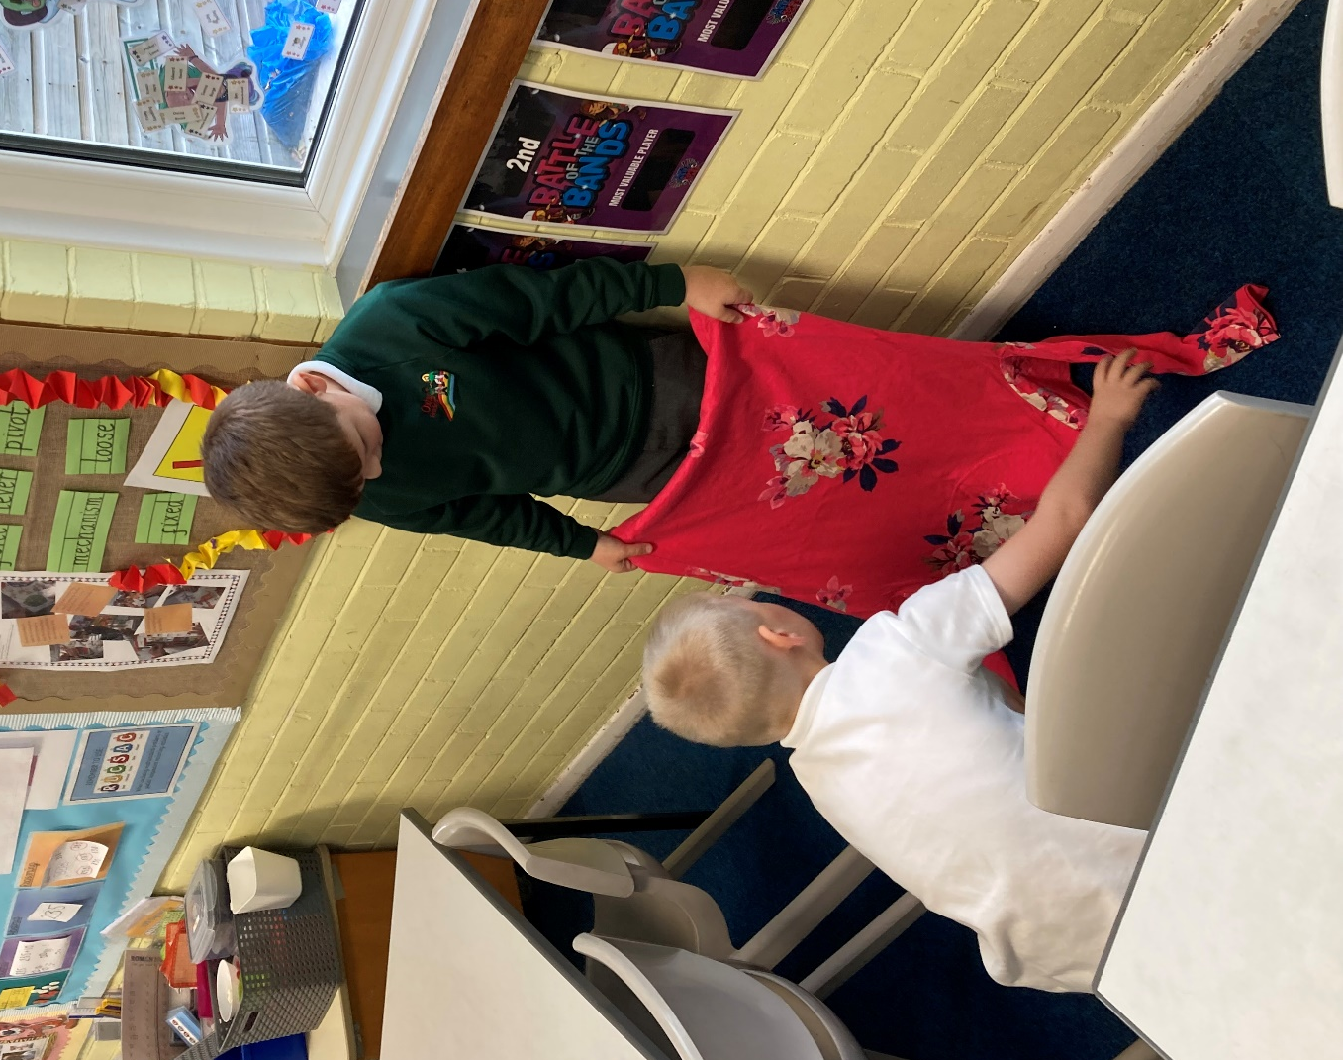
No excuses now for untidy clothes and bedding! Life skills Club practised folding and even getting a duvet into a duvet cover!

