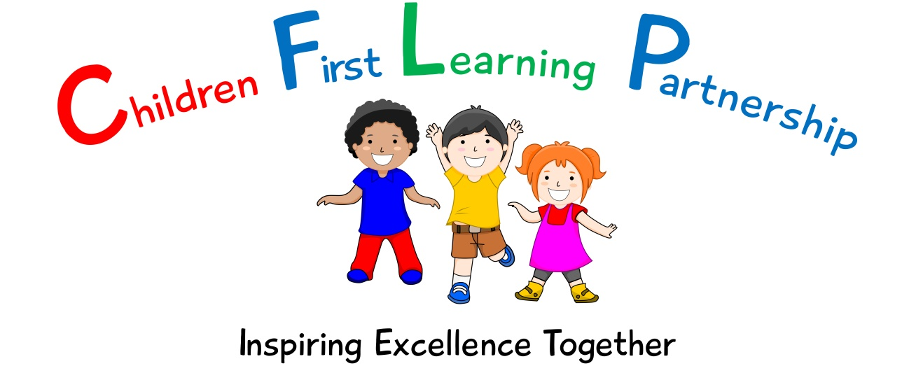

PE Policy for
Oxhey First School
2022-2023

February 2024 or earlier if required
To be reviewed:

Agreed and ratified by the Directors Board
CEO – Mrs A Rourke
Responsible Officer:
Mrs M. Shenton
Chair of Board:
The Maths Policy 2022-2023 in respect of Kingsfield First School has been discussed and adopted by the Children First Learning Partnership Directors Board

INTENT
2.1 At our school, we provide rich and varied learning opportunities that allow all children to build knowledge and develop their skills and abilities to their full potential. Underpinning this are our eight core values of:-

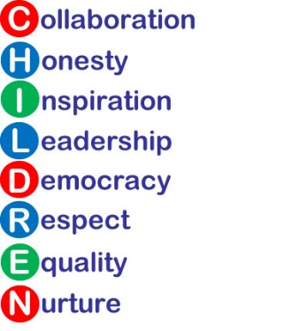

Children First Learning Partnership
PE Policy 2022

The overall intent of our school curriculum is to:
Recognise uniqueness: in our pupils, staff, resources and whole school community.
Be Inclusive: recognising learning styles, learning needs at all levels and providing solutions to any barriers to learning we encounter.
Engage and Inspire: Through knowledge rich, highly enriched, progressive and purposeful contexts.
Promote Aspiration: offering challenge, accountability and responsibility for their learning.
Create citizens of the Future: who thrive on responsibility, see difference as a strength of our community and use democracy to embed their own values and beliefs.
Our Maths curriculum strives to drive all of these intentions and links very closely to the achievement and development of them all.
Intent
To broaden opportunities for children to enjoy a range of experiences and promote a healthy lifestyle. This will enable them to achieve personal successes, develop the appropriate skills and confidence to participate in all physical activities.
Implementation-
A Unit of Work (Pathway)
Across the Children First Learning Partnership, a unit pathway enables all staff to have a clear understanding of how individual, sequenced components enables all children to have a clear composite understanding of each unit. Each unit will consist of:
- National Curriculum programmes of study
- PEDPASS scheme is followed
- Prior learning – find out what the children do or don’t already know/ gaps in learning from the year previously and current year to ensure appropriate components are positioned to make subsequent learning possible.
- Key skills are taught and built up upon (component)
- Key skills become fluent through compositional devices and tactics being introduced (component)
- Fluent components are applied into sequences, games and competitive settings where children can be self and peer evaluative to allow them to become autonomous
- Individual, sequential component lessons (football) build throughout the unit and are applied regularly to the building composite final piece / game/ sequence

A Lesson
Within each and every lesson, there are various sequential components which enables all children to progress no matter their ability. Below shows the sequenced order of a typical Physical Education lesson across the Children First Learning Partnership.

- Warm up (revisit and retrieve knowledge and vocabulary from previous taught components to improve automaticity and make connection to scene)
- Share specific LO (new component), mantra and context to the lesson and how it links to previous components
- Introduce new vocabulary and use in context
- Model and teach new component, linking new vocabulary and use scaffolding learning when needed
- Practise and repeat new component to ensure fluency.
- Apply and master component by combining it with previously taught components in a slowly built up composite
- Evaluate and reflect on the new component linking back to the LO.

Lessons are planned from the correct year groups Programmes of Study from The National Curriculum. Teachers will be aware of the pre units that need to be secure from previous year groups to ensure new content can be understood. The Programmes of Study are then broken down into smaller steps to ensure lessons are driven by sharp learning objectives that are progressively linked.

Individual lessons are carefully designed using the most effective teaching materials so that pupils are given the best opportunities to show their understanding.

Physical Education Language
Across the Children First Learning Partnership, we understand that Physical Education language is crucial to children’s Physical Educational thinking. We introduce new words from the curriculum in a suitable context, with relevant real objects and equipment, explaining their meanings carefully.

In most lessons children work in pairs and groups; discussing, explaining, disagreeing and evaluating each other performances , which is integral to building understanding. Children work together so that through their dialogue they can develop a much stronger understanding.

All adults model the correct use of Physical Educational language and insist pupils do the same. Sentence stems are used to support children to speak about their work in full sentences using the correct terminology. Children understand and remember skills far better when an answer is given within a sporting context.

Pitch, Pace and Challenge
Across the Children First Learning Partnership, the expectation is that the majority of children will move through the units of work at broadly the same pace. However, decisions about when to progress will always be based on the security of children’s understanding and their readiness to progress to the next stage. Children who grasp concepts rapidly will be challenged through the use of the STEP model, which extends skills through the change of space, time, equipment and participants. Those who are not sufficiently secure with earlier skills will consolidate their understanding, including additional practice, before moving on.
Physical Educational Knowledge
Embedded and secure skills and understanding is vital for success in Physical Education. It is likely that children who have problems retrieving gymnastic, dance and games skills and knowledge will have difficulty understanding, using, building upon, applying and evaluating Physical Educational skills they encounter later on in their lessons. Across the Children First Learning Partnership, we ensure that children are given ample opportunities to develop and build on these skills through well planned sequential lessons that build on the previous year’s knowledge. At the beginning of all lessons, children will demonstrate (retrieve) previous skills and knowledge to ensure that all children are ready to move on.

Impact-
What we aim to achieve from our Physical Education curriculum across the Children’s First Learning Partnership

- ‘Mastery’ is something we want all children to achieve and involves utilising a range of strategies to help children develop a deep and secure knowledge and understanding of Physical Education.
- All staff model positive attitudes towards Physical Education and a belief that all pupils can succeed.
- All children will be able to:
  - show a positive attitude and develop a love of physical activity, that takes place in clubs and outside of school.
  - take part in regular physical activity for at least 60 minutes per day (inside and outside of school).
  - show an understanding of how to lead a healthy and happy lifestyle through a correct diet and physical activity
  - use the correct language within PE and to improve the performance of myself and others.
  - swim at least 25 metres before the end of Year 6 and to be able to be safe around water.
  - take part in a range of activities as individuals, groups and teams, applying skills, communicating well and choosing tactics effectively.

Assessment
Our impact will be measured by using formative assessment through the use of ‘Evidence Me’.
Formative
Pupils’ progress is formally assessed and tracked using the Devon PEDPASS ‘expectation statements’ and the ‘core tasks’. The ‘expectations’ and ‘core tasks’ form the basis of teachers’ planning as all learning outcomes are covered within these tasks. This then allows teachers to be creative in the delivery of their lessons. Class teacher takes photographic evidence in lessons, forming an integral part of monitoring and assessment in all the units.
Early Foundation pupils begin to work towards the EYFS goals and are assessed against the Early Years Foundation Stage profile regularly throughout the year.
All pupils are asked to reflect on their own learning and progress during each lesson. Pupil attainment and progress is also communicated through positive teacher and peer encouragement and discussions.
All this information allows teachers to adapt their teaching so it builds on children’s existing knowledge, addresses their weaknesses, and focuses on the next steps that they need in order to make progress.
Across the Children First Learning Partnership, assessment in Physical Education is continuous. From the beginning of every lesson, teachers and teaching assistants will be assessing what their children are, or are not understanding and use this to scaffold each segment of the lesson. Interventions will be ‘live’, meaning that misconceptions are dealt with immediately and high attaining children are challenged appropriately. We pride ourselves in our use of AFL to identify and direct children’s next steps in learning. Our staff are highly skilled to provide a personalised and flexible curriculum for individual children that may need reasonable adjustments to the curriculum. These adaptations increase access to the lesson content enabling them to reach their full potential.
Effective feedback is an important element of teachers’ responses to children’s learning. This will be given orally and is always:
- specific, accurate, and clear
- celebrates success
- compares what a pupil is doing right now with what they have needed to improve before
- provides specific guidance on how to improve as their next step

Role of Leaders
- It is the responsibility of the subject leader to:
- Provide guidance and ensure training opportunities are arranged to enable staff to increase confidence, expertise and quality of delivery.
- Judge standards in PE
- Monitor the quality of teaching and learning in PE
- Lead sustainable improvements in the subject
- Oversee the effective spend of the Primary Sports Funding and evaluate the impact of this
- Ensure all staff have up access to up to date relevant planning documents and information.
- Oversee that resources/equipment are maintained, repaired or replaced.
- Provide clear updates to the Local Advisory Board, Headteacher and SLT.

Staffing
All teaching staff are expected to teach and oversee physical education for their class following the National Curriculum through the schools planning units. PE is taught by a member of the teaching staff or a competent Teaching Assistant if the teacher is unavailable.
Wider PE activity and Sports Offer
In line with the government Obesity Strategy we value the input that physical Children’s First Learning Partnership supports pupils to meet the health recommendations of being physically active for at least an hour a day (3 hours for under 5 years olds) A broad range of out of hours activities is offered after school. They may be delivered by teachers, coaches or parents who have the necessary qualifications. Registers must be taken for all out of hours activity sessions.
To further account for the 3rd NC aim- Engage in competitive sports and activities- We believe that all children should have opportunities to engage in competitive sports and activities. Children will be given the opportunity to take part in a range of competitive events with other schools in the cluster throughout their time within the school, particularly in KS2.
We aim to promote active participation of all pupils within the school day by using resources such as Jump Start Johnny, go noodle and BBC supermovers.
Safe Practice
The general teaching requirement for health and safety applies to this subject. We encourage pupils to consider their own safety and the safety of others at all times. All staff have access to a copy of the afPE publication, which states safety guidelines ‘Safe Practice in physical education’ (2020) and we follow the safe teaching principles outlined in this book as per Staffordshire County Council guidance. All accidents, no matter how slight should be reported via the first aid slips. Any child requiring an inhaler will take it outside for PE. All adults working at the school have a responsibility to report any defects in equipment which require attention. The safe use of equipment will be encouraged at all times and pupils will be trained to move and store equipment in a safe manner.
Risk Assessment
It is the responsibility of all adults leading activities to ensure that they are satisfied that risk assessment procedures have been undertaken and that appropriate measures have been put in place where necessary. Please note that gymnastics equipment must be checked by teachers before any pupil is allowed to use it. Risk assessments can be found in the staff area risk assessments folder.
Clothing
We expect pupils to arrive for physical education in the agreed clothing for each activity.
The school advises parents on what we believe (and the LEA advise) to be appropriate clothing for physical education. All pupils must wear shorts/ jogger/ leggings,
PE T-shirts and jumpers for PE lessons depending on the weather. Should a child not have appropriate kit, they will be expected to take an active role in the lesson, evaluating, assessing and supporting their peers. Teachers wear appropriate clothing and footwear also.
Footwear
Pupils must wear footwear which is appropriate to the activity when outdoors. This will usually be pumps or trainers. For Dance and Gymnastics which takes place indoors, children are expected to work in bare feet as this allows them to obtain more grip and feeling for their actions. Pupils who have a verucca should also work in bare feet as they can only be passed onto other people through damp environments.
Jewellery
Jewellery (including stud earrings) are not allowed during PE lessons and should be removed before the lesson begins. Any new piercing should be carried out at the beginning of the summer holidays so that jewellery may be removed. This information is communicated to parent through our newsletter and uniform policy.
Hair
Where pupils have long hair (longer than their jaw) this should be tied back so that is does not get caught or restrict vision.
Goggles
The wearing of goggles for swimming is not encouraged but each case is looked at individually if there is a medical need.

Version Control

Version | Review Date | Changes Made
V1 | 18.10.2022 | New policy written in a new format.

