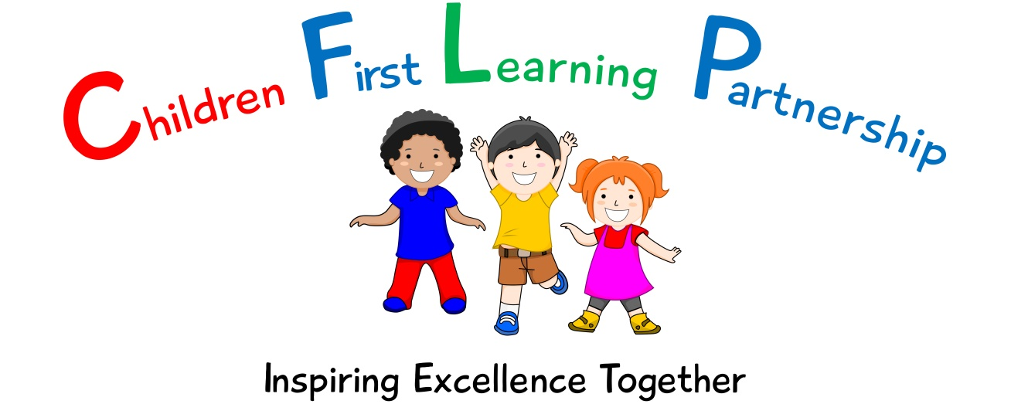

**Careers Policy**

**2023-2024**



**Contents**

1. Statement of Intent
2. Legal Framework
3. Rationale
4. Aims of the Policy
5. Responsibility
6. Learning
7. Parents and Carers
8. Challenging Stereotypes
9. Partners
10. Monitoring and Evaluation
11. Equal Opportunities
12. Review

**1.Statement of Intent**

The main aims of careers provision at Oxhey First School are to:

* Prepare pupils for life post-education.
* Develop an understanding of different career paths and challenge stereotypes.
* Develop an understanding of the differences between school and work.
* Inspire pupils to chase and achieve their dreams.
* Offer targeted support for vulnerable and disadvantaged young people.
* Instil a healthy attitude towards work.
* Assist pupils in recognising their own talents and skills and how these are transferrable to the world of work.

**2.Legal Framework**

This policy is underpinned by Sections 42A and 45A of the Education Act 1997, and has due regard to the DfE’s statutory guidance, ‘Careers guidance and access for education and training providers’, which was last updated in October 2018. The policy is also compliant with legislation and statutory guidance, including, but not limited to, the following:

* DfE ‘Careers guidance and access for education and training providers’ 2018
* Education Act 1997
* Education and Skills Act 2008
* Apprenticeships, Skills, Children and Learning Act 2009
* Equality Act 2010
* Children and Families Act 2014
* Technical and Further Education Act 2017
* The School Information (England) (Amendment) Regulations 2018

**3.Rationale**

We recognise that our curriculum has further potential as a driver to raise our pupils’ awareness of a broad range of occupations and routes to achieve them. We also acknowledge that the breadth of transferrable skills, such as speaking and listening, problem solving, leadership, teamwork and creativity, essential in a range of professions, can also be further promoted within teaching and learning opportunities. With regard to the local context of employment by occupation, the 2021 Census and Labour Market Statistics for Staffordshire Moorlands detail that only 19.2% of employed adults within the locality held professional occupations, compared to 26% nationally,. It is therefore appropriate to inform our pupils of a wide range of careers available to them and raise awareness and aspiration.

**4. Aims of the Policy**

The purpose of the policy is to ensure that there is a clear structure to the careers-related learning offered across the school. This is not about offering careers advice but about broadening horizons, raising aspirations and giving children a wide range of experiences of the world including the world of work. It is about opening doors, showing children the vast range of possibilities open to them and helping to keep their options open for as long as possible. Children will also be given the opportunity to reflect on their own skills and talents and the career paths which they may lend themselves to.

**5. Responsibility**

Whilst all staff will play an integral part in the delivery of careers-related learning, at Oxhey First School, a member of the Senior Leadership staff will be responsible for leading the careers curriculum.

**6. Learning:**

Careers at Oxhey First School is not taught as a discrete subject, but is planned to provide pupils with opportunities to discuss and learn skills required in the world of work. Each year group will focus upon a selection of careers which directly relate to the areas of their learning for that year. This allows pupils to make connections between their own learning and how the skills and knowledge can be applied in the world of work.

The school will work to encompass careers education and guidance into subjects across the curriculum. All teachers will be asked to support the career development of young people in their role and through their subject teaching.

The school will engage with local employers, businesses and networks, inviting visiting speakers to share experiences of their profession and daily working lives, as appropriate. The school will endeavour to strengthen community links through these partnerships.

The school will plan events to support career choices and aspirations, throughout the academic year. These may include:

* Guest Speakers
* A career’s week
* Parental engagement sessions linked to careers
* Careers Fair
* Business enterprise
* Links with other schools

**7.Parents & Carers:**

Parents and carers are encouraged to contribute to the school’s careers programme. Parents and carers, along with the wider community will be invited to share their skills and work experience with pupils to broaden pupil’s awareness of future career possibilities. Parents and carers will also be invited to partake in career related activities such as:

* Parental engagement events – SHINE sessions
* Careers Week
* Careers Fairs

**8. Challenging Stereotypes:**

An aim of the Careers Curriculum is to challenge stereotypes through discussion and challenge. Pupils (and parents through our Parental Engagement Sessions) will take part in discussions around careers and job roles. This will allow any preconceptions to be identified and challenged through discussion and questioning. Through this approach, we hope that Oxhey First School pupils are able to develop aspirations for the future and broaden their understanding of potential careers and access routes (including training and qualifications).

**9.Partners:**

We intend to develop partnerships with the local community in delivering our careers curriculum. These may include:

* Local businesses
* Local schools
* Local services including the Police, Fire Service, School Nurse and medical professionals

**10.Monitoring and Evaluation:**

Monitoring and evaluation will be conducted by the Careers Curriculum Leader, and the Senior Leadership Team. Internal monitoring of Careers in the Curriculum ‘big books’ will be conducted throughout the year. Pupil and parent voice will also be considered in evaluating the success and effectiveness of the Careers Curriculum.

**11.Equal Opportunities:**

Oxhey First School promotes equal opportunities, challenges stereotypes and addresses limiting beliefs. Careers in the Curriculum lessons will challenge existing stereotypes and encourage all to participate equally. Oxhey First School will ensure that all pupils can participate in projects and activities by providing resources and appropriate scaffolds, where required.

**12. Review**

This policy will be reviewed every 2 years.

This policy has been agreed following consultation with all staff, pupils, parents and the Local Advisory Board.

Signed: (Headteacher) .……………………………………………………….………

Date: ……………………..……………

Signed: (Chair of Local Advisory Board) …………………………………………

Date:……………………..………

The policy will be reviewed ………………………February 2024