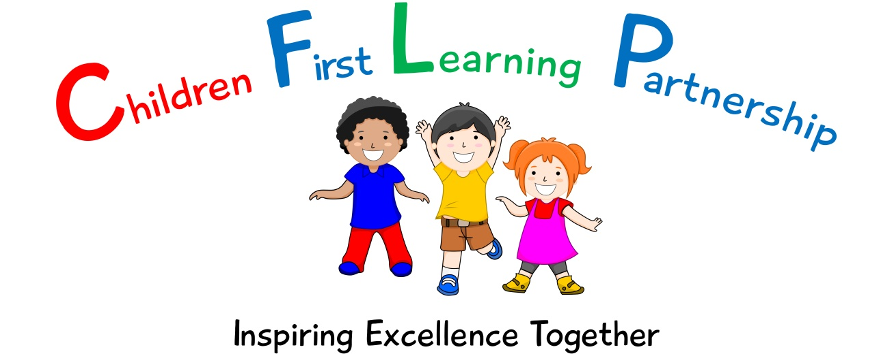

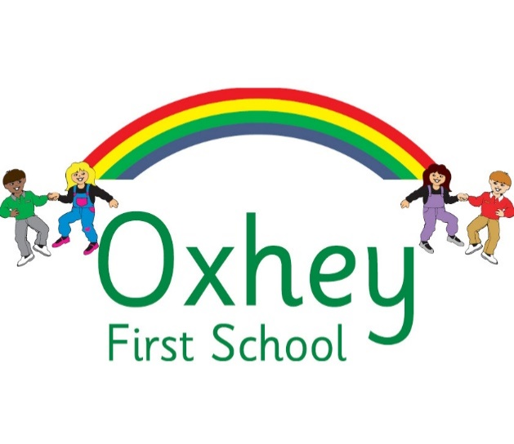

Art Policy 2023

February 2024
To be reviewed:
________________
Agreed and ratified by the Local Advisory Board on:
Headteacher – Mrs L Jukes

Responsible Officer:
Mrs. M Shenton
Chair of Local Advisory Board:
The CFLP Art Policy in respect of the Children First Learning Partnership has been discussed and adopted by the Local Advisory Board.

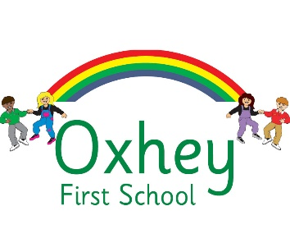

Art Policy 2023

The overall intent of our school curriculum is to:
Recognise uniqueness: in our pupils, staff, resources and whole school community.
Be Inclusive: recognising learning styles, learning needs at all levels and providing solutions to any barriers to learning we encounter.
Engage and Inspire: through knowledge rich, highly enriched, progressive and purposeful contexts.
Promote Aspiration: offering challenge, accountability and responsibility for their learning.
Create citizens of the Future: who thrive on responsibility, see difference as a strength of our community and use democracy to embed their own values and beliefs.
Our Art curriculum strives to drive all of these intentions and links very closely to the achievement and development of them all.

Intent
To develop children’s experience of Art by imagining, creating and exploring through different mediums.
We aim to achieve this through allowing the children:
- To develop a broad knowledge and understanding of a range of famous artists, craft makers and designers.
- To develop knowledge and understanding of shape, pattern, colour, texture and form to express emotions and individuality.
- To show a passion and enjoyment for artwork.
- To draw confidently and adventurously from observation, memory and imagination.
- To select and use materials and techniques skilfully and inventively that are fit for purpose.
- To develop independence, initiative and originality which they use to develop their own and others’ creativity.
- To be able to reflect, talk about and improve their own work and that of others.

Implementation
We use the Development Matters and National Curriculum documents to inform the delivery of Art and Design at Oxhey First School.
Our progression documents show a build-up of knowledge and skills across the following areas:

KS1 – children use a range of materials to design and make products; use drawing, painting and sculpture to develop and share ideas, experience and imagination; to develop a wide range of Art and Design techniques in using colour, pattern, texture, line, shape, form and space; learn about the work of a range of artists, craft makers and designers, describing the differences and similarities between different practices and disciplines, and making links to their own work; begin to use sketchbooks to explore new ideas and revisit skills.

KS2 – children learn about and take inspiration from notable artist/architects/designers, to master a wide range of Art and Design techniques in using colour, pattern, texture, line, shape, form and space; and create sketchbooks to record their observations and use them to review and review and revisit ideas.

Art and Design Techniques

In order to ensure the depth and breadth of our Art curriculum, it has been designed in a way in which each key stage covers a range of units across a rolling Cycle A and B. This ensures that the mixed age-group classes all cover the appropriate units during their time in both Key Stage 1 and Key Stage 2.

As children are initially exploring and building the foundations of their skills and understanding in Key Stage 1, each technique is covered in both Year 1 and again in Year 2 via different units to ensure that children have opportunity to build a breadth of experience across different techniques. In Year 3 and 4, children cover all techniques for a longer period in greater depth across the two-year cyclic A and B programme, ensuring that they have time and opportunity to explore, experiment and create in greater detail and depth.

In Key Stage 1, children cover: Drawing, Printing, Painting, Collage and Sculpture each year.

In Key Stage 2, children cover: Drawing, 3D Modelling Sculpture and Printing in Year A, Collage, Painting and Clay Sculpture in Year B.

See Art Skills Overview for further detail.

Artists

A focus artist (see Curriculum Overview) is covered as part of each Art and Design unit that is taught. This is to ensure that children gain a depth and breadth of knowledge regarding artists, craft makers, designers and architects. We ensure that children study artists from a range of ethnicities, cultures and backgrounds in order to expose children to the wider world and support their cultural capital.

The children’s artwork can be a replication of the studied artists’ content or technique, or inspired by elements of the artists’ work.

Sketchbooks

Children will be provided with a sketchbook from the start of Year 1. This will then follow them through the school to the end of Year 4. When one sketchbook is filled a new one will be provided.

Sketchbooks are working documents that will demonstrate children’s exploration and experimentation of different research, skills and techniques. Children are encouraged to make annotations as they work so that the sketchbook can be used to inform a final piece.

Learning objectives are stuck in via a label to ensure that children know the intended outcome of the lesson and these can be used as a tool when looking back on previous learning.

Sketchbooks are not marked – feedback is given live during the moment.

Celebrating Art

Final pieces of artwork are created in a variety of ways and are not restricted to a sketchbook. This allows for children’s artwork to be celebrated and presented in different ways, such as through displays, social media and being shared with family members.

Once final pieces are taken off display, they are added to a child’s individual Art Portfolio folder. These Art portfolios follow each child along their journey through Year 1-4, meaning that, by the end of their time at Oxhey, every child has a collection of art to celebrate and show their progression as an artist.

Unit Structure
A unit of work typically incorporates the following:
- National Curriculum Programmes of Study are used, alongside our subject specific progression documents, for long term and medium-term planning.
- An Artist study is used to explore techniques, meaning and content of artwork, which the children can use to inspire their own artwork.
- Prior Learning- this is achieved through targeted questioning and the analysis of a prior learning which demonstrates the children’s strengths and areas for development.
- Vocabulary - a wide range of Art and Design vocabulary is to be modelled and used in context to demonstrate understanding. The vocabulary documents set out clear expectations for each year group.
- Teach and model - specific Art and Design techniques that the children are given time to refine before applying them to their own piece of artwork.
- Application – children’s knowledge and skills of the unit to be applied in a final composite piece of work.
- Evaluate – children take part in ongoing self-reflection throughout the unit culminating in a formal, constructive critique of their final artwork.

Lesson Structure
Lessons are planned from the correct Key Stage Programmes of Study from The National Curriculum and our progression documents. Teachers will be aware of the prior learning that needs to be secure from previous year groups to ensure new content can be understood. Lessons are planned sequentially, to ensure knowledge and skills are built upon.

A lesson would typically consist of the following:
- Retrieve - used to revisit and retrieve previously taught knowledge/skills that are relevant/applicable to today’s learning.
- Shared learning objective, success criteria and unit specific vocabulary - help to set the context for a lesson.
- Teaching exposition - a variety of strategies are used to model and explore new concepts.
- Opportunities to discuss learning - children are encouraged to speak in full sentences and reinforce vocabulary in context.
- Assessment for learning (AfL) questions - used to extend and/or support learning.
- Practise/Apply – a range of opportunities to embed skills/knowledge taught.
- Scaffolded learning activities - linked to the learning objective to ensure all children achieve the learning outcome.
- Reflection – a range of techniques are employed to encourage children to think about and discuss their own learning.
- Evaluate – refer back to learning objective and success criteria. This could be at any point throughout the lesson.
These elements could be used flexibly throughout each session.
Impact
What we aim to achieve from our Art curriculum across the Children First Learning Partnership:
Children will:
- have a broad knowledge and understanding of a range of famous artists, craft makers and designers.
- have a broad knowledge and understanding of the formal elements of Art.
- be able to produce artwork that expresses emotion and individuality.
- foster a passion and enjoyment for artwork.
- be able to draw with confidence from observation, memory and imagination.
- be able to select and use materials and techniques skilfully and inventively.
- be able to select and use materials that are fit for purpose.
- be independent and willing to take creative risks.
- use their initiative and originality to develop their own and others artwork.
- be able to reflect, talk about and improve their own work and that of others.
Assessment
Assessment within Art is based upon many sources of evidence. This will allow for judgements to be evidenced based and secure regarding what pupils know and remember in relation to our planned curriculum outcomes in all year groups. Teachers will use a variety of assessment methods which they will select carefully based upon the quality of evidence it will provide within Art and will avoid additional workload for pupils and children.

Formative Assessment:
Formative assessment takes many forms in Art:
Assessment for Learning:
Teachers and subject leaders value the voice of the pupil.’ They will observe pupils carefully, question purposefully and listen and use pupil responses in all lessons and the day-to-day life of the school to adapt teaching in the moment, lesson to lesson and unit to unit to ensure learning is secure and built upon in a sequential and progressive manner. In many lessons and where appropriate, purposefully planned explicit retrieval opportunities will also be used to ensure pupils have secured component knowledge and are ready to move on and make links to previous learning.
Evidence Me
Where appropriate, a wealth of other evidence such as practical hands-on learning, behaviours, drama, performances and group work will also be captured on Evidence Me to support teacher assessment judgements. At Oxhey, we value talk, practical exploration and pupil responses as a method of ensuring all pupils can access our Art curriculum and demonstrate the gains they are making simply and effectively.
Summative Assessment:
Summative assessment in Art may be available in some year groups to aid the judgements teachers make about what pupils know and remember:
Sketchbooks and ‘Final Piece’ Composite Outcomes
Pupils, will where appropriate, capture their understanding, evaluate their own learning or rehearse and secure knowledge in a written form. This will be used effectively to evidence progress and avoid creating barriers to learning for any group of pupils in our school, for example due to their age or any additional needs they may have.
Teacher Assessment Judgements
Children will be judged as meeting curriculum expectations in Art on a termly basis using evidence from activities listed above. This judgement will be working at, below or at a greater depth within the year group/key stage unit they have completed. This will be captured on our Arbor system and used to inform curriculum design and developments, resourcing, training and leadership monitoring activities. Teacher assessment judgements in Art will be shared with parents on an annual basis via their annual report.

Role of Leaders
- Lead the development of Art and Design in the school, including identifying the next steps and driving the subject forward.
- Provide CPD opportunities (training, staff meetings, planning clinics, drop-ins and ongoing support) to develop staff.
- Conduct leader research to ensure the subject knowledge and understanding of the leader is up to date. This is disseminated to staff when appropriate.
- Review, monitor and feedback current practice within the subject.
- To ensure that all resources are available for each unit.
Version | Review Date | Changes Made

