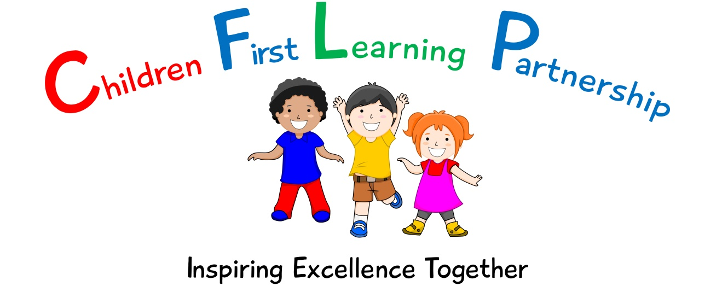

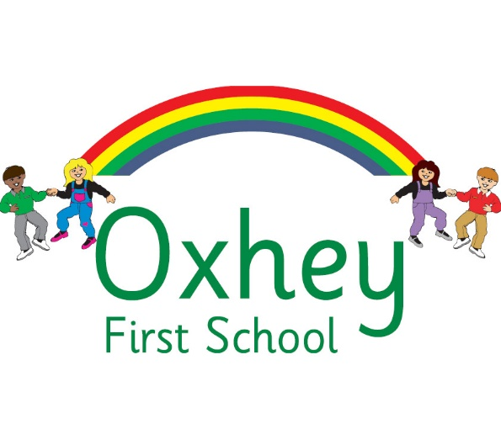

Modern Foreign Languages Policy 2023

May 2024
To be reviewed:
________________
Agreed and ratified by the Local Advisory Board on:
Headteacher – Mrs L Jukes

Responsible Officer:
Mrs. Margaret Shenton
Chair of Local Advisory Board:
The CFLP Modern Foreign Languages (MFL) Policy in respect of the Children First Learning Partnership has been discussed and adopted by the Local Advisory Board.

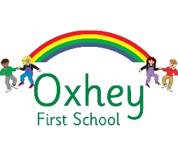
Oxhey First School
Modern Foreign Languages (MFL) Policy 2023
Intent
The overall intent of our school curriculum is to:
Recognise uniqueness: in our pupils, staff, resources and whole school community.
Be Inclusive: recognising learning styles, learning needs at all levels and providing solutions to any barriers to learning we encounter.
Engage and Inspire: through knowledge rich, highly enriched, progressive and purposeful contexts.
Promote Aspiration: offering challenge, accountability and responsibility for their learning.
Create citizens of the Future: who thrive on responsibility, see difference as a strength of our community and use democracy to embed their own values and beliefs.
Underpinning this are our eight core values of:

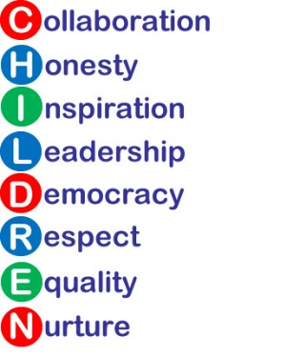

Our Modern Foreign Languages (MFL) curriculum strives to drive all of these intentions and links very closely to the achievement and development of them all.
Our specific intent for MFL at Oxhey First School is to develop the teaching and learning of French across Key Stage 2 and prepare children for future opportunities in French speaking countries.

We intend to enable our Key Stage 2 pupils:
- To understand where French is spoken and the culture of the country.
- To be passionate about French and want to understand the language.
- To use French creatively and freely when they choose.
- To speak French with confidence including good expression and punctuation.
- To use imagination when writing in French.
- To read with fluency in French.
- To take responsibly for their learning and use dictionaries and other resources when needed to.

Implementation
We use the National Curriculum documents to inform the delivery of MFL and Design at Oxhey First School. In addition, we use schemes of work such as Rigolo to support with the effective delivery of the curriculum.
Our progression documents show a build-up of knowledge and skills in MFL. Teaching provides an appropriate balance of spoken and written language and lays the foundations for further foreign language teaching at key stage 3. It enables pupils to understand and communicate ideas, facts and feelings in speech and writing, focused on familiar and routine matters, using their knowledge of phonology, grammatical structures and vocabulary.

A Unit of Work (Pathway)
Across the Children First Learning Partnership, a unit pathway enables all staff to have a clear understanding of how individual, sequenced components enables all children to have a clear composite understanding of each unit. Each unit will consist of:
- National Curriculum programmes of study
- Prior learning – find out what the children do or don’t already know/ gaps in learning from the year previously and current year to ensure appropriate components are positioned to make subsequent learning possible.
- Warm up- key components are revisited from previous lessons
- Share specific LO and what is to be achieved by the end of the unit
- WAGOLL- model and teach new component and vocabulary
- Practice- repeat new components to ensure fluency and practice these
- Apply- new components are applied with previously taught components in the composite
- Evaluate- reflect on the new components that have been taught

A Lesson (Pathway)
Lessons are planned from the correct Key Stage Programmes of Study from The National Curriculum and our progression documents. Teachers will be aware of the prior learning that needs to be secure from previous year groups to ensure new content can be understood. Lessons are planned sequentially, to ensure knowledge and skills are built upon.

A lesson would typically consist of the following:
- Retrieve - used to revisit and retrieve previously taught knowledge/skills.
- Shared learning objective, success criteria and unit specific vocabulary - help to set the context for a lesson.
- Teaching exposition - a variety of strategies are used to model and explore new concepts.
- Opportunities to discuss learning - children are encouraged to speak in full sentences and reinforce vocabulary in context.
- Assessment for learning (AfL) questions - used to extend and/or support learning.
- Practise/Apply – a range of opportunities to embed skills/knowledge taught.
- Scaffolded learning activities - linked to the learning objective to ensure all children achieve the learning outcome.
- Reflection – a range of techniques are employed to encourage children to think about and discuss their own learning.
- Evaluate – refer back to learning objective and success criteria. This could be at any point throughout the lesson.
These elements could be used flexibly throughout each session.
Impact
Our impact will be measured by using both formative and summative assessment.
Assessment
Assessment within Oxhey First School is based upon many sources of evidence. This will allow for judgements to be evidenced based and secure regarding what pupils know and remember in relation to our planned curriculum outcomes in all year groups. Teachers will use a variety of assessment methods which they will select carefully based upon the quality of evidence it will provide within Oxhey First School and will avoid additional workload for pupils and children.
Formative assessment takes many forms in Oxhey First School:
Assessment for Learning -AfL
Teachers and subject leaders value the voice of the pupil.’ They will observe pupils carefully, question purposefully and listen and use pupil responses in all lessons and the day to day life of the school to adapt teaching in the moment, lesson to lesson and unit to unit to ensure learning is secure and built upon in a sequential and progressive manner. In many lessons and where appropriate, purposefully planned explicit retrieval opportunities will also be used to ensure pupils have secured component knowledge and are ready to move on and make links to previous learning.
Evidence Me
A wealth of other evidence such as practical hands on learning, behaviours, drama, performances, group work will also be captured on evidence me to support teacher assessment judgements. At Oxhey First School we value talk, practical exploration and pupil responses as a method of ensuring all pupils can access our MFL curriculum and demonstrate the gains they are making simply and effectively.

Summative assessment in MFL may be available to aid the judgements teachers make about what pupils know and remember:

Pupils work, end of unit quizzes and composite outcomes
Pupils, will where appropriate, capture their understanding, evaluate their own learning or rehearse and secure knowledge in a written form. This will be used effectively to evidence progress and avoid creating barriers to learning for any group of pupils in our school, for example due to their age or any additional needs they may have.
Teacher Assessment Judgements
Children will be judged as meeting curriculum expectations in MFL on a termly basis using evidence from activities listed above. This judgement will be working at, below or at a greater depth within the year group/key stage unit they have completed. This will be captured on our Arbor system and used to inform curriculum design and developments, resourcing, training and leadership monitoring activities. Teacher assessment judgements in MFL will be shared with parents on an annual basis via their annual report.

Role of Leaders
- Lead the development of MFL in the school, including identifying the next steps and driving the subject forward.
- Provide CPD opportunities (training, staff meetings, planning clinics, drop-ins and ongoing support) to develop staff.
- Conduct leader research to ensure the subject knowledge and understanding of the leader is up to date. This is disseminated to staff when appropriate.
- Review, monitor and feedback current practice within the subject.
- To ensure that all resources are available for each unit.
Version | Review Date | Changes Made

