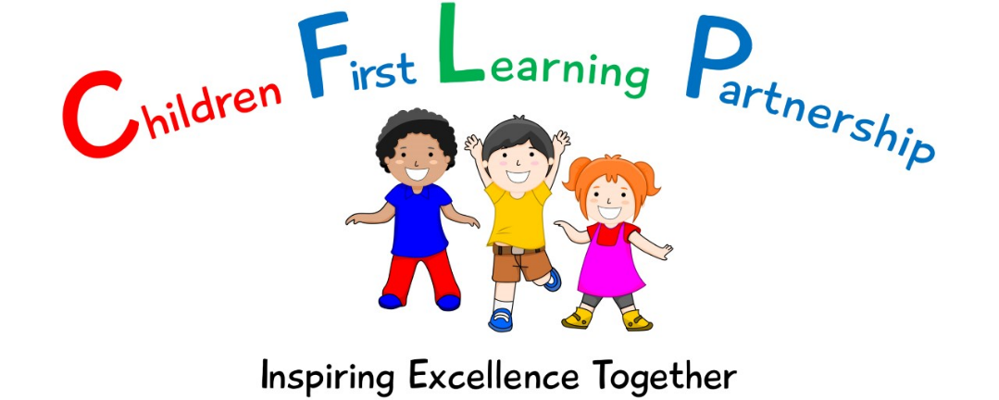

**Positive Behaviour Policy**



June 2023

**\****This policy is based upon the Classroom Culture Crisis Prevention training.*

*June 2024 or earlier if required*

*To be reviewed:*

*03.07.2023*

*Agreed and ratified by the Local Advisory Board on:*

*Oxhey Headteacher- Mrs L Jukes*

*Responsible Officer:*

*Mrs M Shenton*

*Chair of Local Advisory Board:*

The Behaviour Policy in respect of the Children First Learning Partnership has been discussed and adopted by the Local Advisory Board

# Intent

Oxhey First School is a happy, vibrant school where diversity and individuality are celebrated. We are passionate in our pursuit of excellence in all aspects of school life. We nurture and inspire children to develop confidence, independence and resilience in an environment where efforts are valued and all children flourish. Throughout their time with us, pupils are empowered to gain the skills and knowledge to become citizens of the future. On a day-to-day basis our school promotes our Trust’s shared values of:

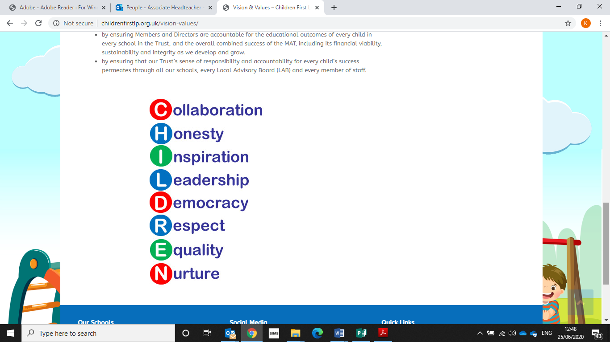

Excellent behaviour is a minimum expectation for all. Everyone is expected to maintain the highest standards of personal conduct, to accept responsibility for their behaviour and encourage others to do the same. We aim to create a culture of exceptionally good behaviour for learning which lays down the blueprint for positive behaviour for life. We encourage our learners to be ambitious for themselves and for others, as we support and challenge them in their learning journey. Staff, children, governors and parents recognise the need for an effective, uncomplicated and consistent approach to positive behaviour in order for high quality teaching and learning to take place. As part of our commitment to this, we have reviewed our behaviour policy and simplified our school rules to enable our whole school community to understand, embrace and remember them. All behaviour in school is underpinned by our three school rules:

* **BE SAFE**
* **BE RESPECTFUL**
* **BE READY**

We want our learners to **be safe** and **feel safe**; safe as they move around school, safe inside and outside the school building which includes being safe on school trips and staying safe online. We want our children to know who they can turn to for advice when they are worried or concerned, within school and outside of school. We aim to build a school community of people who protect not only our own safety but a community who take the time and care to look out for one another.

We want our learners to be **respectful**; to treat others fairly, to develop mutual respect alongside tolerance, patience and understanding, to listen when others speak, to respect others’ opinions, to use and show good manners and to respect class resources and the school environment. Ultimately, we aim to all work together to promote and develop strong, healthy relationships in school and within the local community.

We want our learners to be **ready**; ready to work and learn to their full potential by always doing their very best, ready to listen, ready to help, ready to act for a friend or neighbour in need, ready to lead, ready to give and forgive, ready to have fun and enjoy time in school.

# Implementation

**The Oxhey First School Way - *‘A Happy Place to Learn and Grow’***

* A member of staff will meet and greet every child, every morning.
* There will be a consistency that ripples through every interaction on behaviour from all adults in school.
* All adults in school will model positive behaviours and show a real commitment to building positive relationships; remaining calm and using first attention to best behaviour, praising those who are demonstrating good behaviour and never ignoringor walking past children who are not following our three school rules.
* Provides a curriculum which explicitly explores and defines what good behaviours, relationship and interactions look like within the school environment and beyond.
* We will promote and celebrate specific behaviours (social and/or learning behaviours) through our school motto and our TIGER learning.
* Children who go over and above with their learning or their behaviour will be recognised in our weekly Celebration assemblies through our ’Pupil of the Week’ and ‘TIGER Learner’ awards.
* All adults in school will engage in reflective dialogue with learners, using the given scripts. When needed, restorative conversations will be held with individuals in a quiet space away from others.
* When necessary, pupils in school who persistently struggle to self-regulate against our school rules are supported through a variety of strategies, interventions and external agencies.
* Where monitoring shows a pupil displays more serious or regular repeated negative behaviours, a range of communication between SEND Leaders, Senior Leaders, parents and external agencies with take place as demonstrated in the school’s SEMH Graduated Response.

At the beginning of the school year and throughout the year, all staff work hard to reinforce our three school rules. Throughout the school day, pupils will be reminded of the three school rules through either direct or indirect conversations about whether behaviour is ‘ready, respectful and/or safe’.

Our approach to creating a positive ethos within school is to treat children positively, praising them, offering encouragement and acknowledging their achievements. We will ensure that children know that their effort, achievement and good behaviour are recognised and valued through a range of classroom and whole school strategies, see below:



CLASSROOM

POSITIVE ENCOURAGEMENT, RECOGNITION & REWARDS

* An encouraging smile
* Praise (verbal and written)
* Stickers
* Sharing work with another class/teacher
* House points
* Class behaviour ladder display
* Class rewards

WHOLE SCHOOL

POSITIVE ENCOURAGEMENT, RECOGNITION & REWARDS

* Celebration Assembly
* Headteacher Awards
* Certificates
* Lunchtime Awards
* Attendance Awards
* WOW Awards
* Newsletter celebrations

# Strategies to Manage Behaviour

Children are held responsible for their own behaviour. Staff will address and manage behaviour using the Class Behaviour Display. These are designed to give our children every opportunity to modify and change their behaviour for the better. Our Behaviour Display should always be gone through with care and consideration, taking individual needs into account and giving children time to reflect.

# School Behaviour Logs & Monitoring

Through use of our class behaviour display all red behaviours are formally recorded. Our school has a confidential behaviour log on our Arbor Information System. These are written records of interactions and conversations concerning behaviour. The log is dated and includes relevant information and action taken. Incidents of proven bullying and racism incidents are always reported directly to the Headteacher or Assistant Headteacher.

Weekly reports are generated by Arbor and are analysed thoroughly and discussed regularly by Senior Leaders. Any subsequent actions from these meetings would be in line with our school SEMH graduated response.

These reports are also discussed termly within our Safeguarding Link Governor meetings.

**Class Behaviour Display**

|  |  |
| --- | --- |
| **Behaviour Ladder** | **Expectation-rewards and sanctions** |
| Above and Beyond | Continuously excelling and keen to learn more!  A visit to the Headteacher to choose a prize from the Golden Prize Box, a Headteacher Award sticker and a text message to parents/carers celebrating this achievement. |
| Flying High | Achieving something new for the first time and standing out with super effort.  Silver Certificate Award |
| Keep it Going | Continuing to do the right thing and showing real perseverance with their learning.  Bronze Sticker Award |
| Good to Go! | All children begin each day on Green and show they are doing the right thing and following the school rules. Being fully engaged in their learning.  Classroom rewards – stickers, house points etc. |
| Stop and Think | Low level disruption, and not following the school rules.  A warning is given and a discussion had to support in getting back on to green. |
| Take a Moment | Behaviour not corrected, and continuing to show low level disruption. Children showing disrespect to children or staff.  A further discussion will be had and thinking time in another part of the classroom is given to support a prompt change to more positive behaviour. |
| Time Out | Hurting others or showing aggressive behaviours or damaging school property.  Children moved to another classroom and spoken to by a member of SLT if required. Parents are informed and the behaviour is recorded on Arbor. Restorative practice implemented. |

**PLEASE NOTE**: All of the above actions will be used consistently across the school and class teachers will use their professional judgement regarding actions to take at the most appropriate time. It is **occasionally** possible to leap or accelerate movement for certain behaviours displayed. Aggressive behaviour, fighting or swearing will trigger consequences and lead immediately to recording on Arbor. In these cases, the teacher will use her/his professional judgement to decide whether senior leaders should be asked to intervene immediately.

|  |  |
| --- | --- |
| Restorative Conversations - Scripted Responses The following scripts and planned responses are used by all staff in school and are shared with our children. This encourages a calm, consistent and kind approach and promotes the time needed to encourage restorative conversations. We believe it is these moments and conversations that lie at the heart of positive behaviour and relationship management. | |
| **Warning Script** | |
| **EYFS:**  NAME! STOP! WE HAVE KIND HANDS! (What do you want to see – WE DO GOOD SITING/LISTENING)  I am not taking any notice of your behaviour. You are better than this. If you continue, you will be missing some choice time to think about your choices. Do you remember this morning when you helped me to tidy up/played nicely with ..? Remember how that made you feel? *That* is the name I know, I need to see that name again.  **KS1/KS2:**  Your poor behaviour does not deserve my time. You are better than the behaviour you are showing today. If you continue, you will be missing 5 minutes of your playtime to think about your choices. Do you remember yesterday/last week when you helped me to tidy up/led the group/shared your excellent home learning? Remember how that made you feel? *That* is the person I know, *that* is the person I need to see today. Think carefully about your next step.” | |
| **Stop and Think Script** | |
| **EYFS:**  Even after our chat, I noticed you were …. (having trouble to focus/struggling to get going today/wandering round the classroom/finding it difficult to follow my instructions). It was the rule about … (being ready, respectful and/or safe) that you broken. You have had a think but you’re still not making their right choices. Do you remember this morning when you helped me to tidy up/played nicely with ..? Remember how that made you feel? *That* is the name I know, I need to see that name again. Thank you for listening.” Then give the child some quiet time to calm down and reflect.  **KS1/KS2:**  Even after a warning, I noticed you were …. (having trouble to focus/struggling to get going today/wandering round the classroom/finding it difficult to follow my instructions). It was the rule about … (being ready, respectful and/or safe) that you broke. You have chosen to spend 5 minutes of your playtime with me to discuss your choices. Do you remember last week when you … (arrived on time every day/got our Pupil of the Week/TIGER Learner award) That is who I need to see today …. Thank you for listening.” Then give the child some quiet time to calm down and reflect. | |
| **Take a Moment Script** | |
| **EYFS:**  You have made the wrong choices, and that choice has made me sad. Tell me what you think your wrong choice was for. For that reason you will now have some time out to work in another part of the classroom.  After ‘Time Out’ follow up with …  What do you think you could do to make better choices? It’s not like you to … (kick doors/shout out/hurt people/break things). I care about what happens for the rest of today. If you choose to…..play nicely, do your learning, then would be fantastic and then you can move back up the ladder. …If you chose not to make the right choice, then we will have to have a chat with Mrs Cooper/Mrs Holt/Mrs Christie/Mrs Taylor/your parents.  **KS1/KS2:**  You need to understand that every choice has a consequence. Tell me what you think your poor choices were…For that reason you will now have some time out to work in another part of the classroom.  After ‘Time Out’ in another part of the classroom follow up with …  What do you think you could do to avoid this happening in the next lesson? It’s not like you to … (kick doors/shout out/put little effort in). I care about what happens for the rest of the day/week. If you choose to…..do the work, that would be fantastic and this will happen…If you chose not to do the work, then we will have to have a discussion with Mrs Cooper/Mrs Holt/Mrs Christie/Mrs Taylor/your parents. | |
| **Time Out - Restorative Questions** | |
| **EYFS**   * Tell me what happened? * What were you feeling at the time? * Who has been upset by your wrong choices? * How can we put things right? * What can we do differently tomorrow? | **KS1/KS2**   * Tell me what happened? * What were you thinking about at the time? * What have you thought since? * How did this make people feel? * Who has your behaviour affected? * How do you think your behaviour has made them feel? * What should we do to put things right? * How can we do things differently in the future? |

# Education for a Connected World

Oxhey First School promotes the highest standard of behaviour in all areas of school life including around online safety. Children are expected to follow the online safety guidelines and to be respectful and uphold the standard of behaviour expected at all times. Through Relationships Education and Health Education, pupils will be taught about online relationships, being safe (including in a digital context) and online safety and harms. Teachers will address online safety and appropriate behaviour in an age-appropriate way that is relevant to our pupils’ lives through the ‘Education for a Connected World’ framework. The framework is central to our whole school approach to safeguarding and online safety; complimenting and broadening our curriculum and provision of online safety education. It focuses specifically on eight different aspects of online education:

1. Self-Image and Identity
2. Online Relationships
3. Online Reputation
4. Online Bullying
5. Managing Online Information
6. Health, Wellbeing and Lifestyle
7. Privacy and Security
8. Copyright and Ownership

The objectives promote the development of safe and appropriate long-term behaviours. It also supports our teachers in empowering our pupils and building their resilience. We aim to give our pupils the information that they need to make good decisions about their own health and wellbeing which includes teaching children how to be safe online and the impact social media and the internet can have on their wellbeing. The framework details the skills and understanding that children should develop as they progress through our school.

# Promoting Positive Well-Being and Mental Health

At Oxhey First School, pupils will also learn how to build their confidence, independence and resilience so they can keep themselves mentally healthy. The skills, knowledge and understanding needed by our pupils to keep themselves and others physically and mentally healthy and safe and knowing how and when to ask for help if problems arise are included as part of our PSHE curriculum. We also celebrate national celebration events such as Children’s Mental Health Week, Anti-Bullying Week . We strongly believe that a healthy body means a healthy mind and, therefore, we promote and support children in understanding that good physical health contributes to good mental wellbeing, and vice versa.

# Pastoral Support – Interventions and Support Strategies

As part of our pastoral programme, we will endeavour to identify and support those pupils who are more vulnerable. We offer a variety of classroom strategies that complements the promotion of emotional wellbeing of pupils in our school, such as:

* Emotion boards
* Worry boxes
* Anti-bullying Ambassadors / Pupil Leadership groups (Playground Buddies & Peer Mediators)

Beyond the classroom, support may include:

* Trailblazers
* SEMH interventions-individual and classroom
* SEND hub referral
* Graduated Response
* Outreach Support

Interventions do not aim to solve *all* the pupils’ difficulties. They will target the priority need at the time and we will utilise other services to help where and when necessary. We also have quality resources, books and activities that help to build pupils self-esteem, resilience, increase inner calm, manage anger, improve understanding of emotions and encourage positivity.

# Positive Classroom Culture

At Oxhey First School, we feel passionately about empowering our children to have a ‘growth mindset’ which enables them to love learning and strive to be the very best that they can be. The children’s capacity to develop a growth mindset is underpinned by Oxhey’s School Way- *A Happy Place to Learn & Grow*, our TIGER learning and our whole school ethos. It is further developed through whole school assemblies and the wider curriculum.

**We aim to achieve:**

* A love of learning and a desire to improve.
* A desire to be challenged.
* A resilience and willingness to work for a positive result.
* A belief that with effort and practice you can achieve anything.
* An understanding that you can learn from your mistakes and failures.
* Self-motivation and resilience.
* Being proud of all of your achievements.

# Anti-Bullying

Bullying in any form will not be tolerated at Oxhey First School. Bullying is the unwanted behaviour towards another person over a period of time. If we discover that an act of bullying has taken place, we act immediately to stop any further occurrences of such behaviour. (Please refer to our Anti-Bullying Policy and Child-Friendly Anti-Bullying Policy).

# Equal Opportunities and Entitlement for All

The safety, welfare and well-being of all pupils and staff is a key priority at Oxhey First School. We actively promote values of respect and equality and work to ensure difference, diversity and inclusion is celebrated across the whole school community; promoting respect and equality across all protected characteristics, including sexual orientation, gender identity and family diversity, as we prepare pupils for life in diverse 21st Century Britain. These values reflect those that will be expected of our pupils by society, when they enter middle school and beyond in the world of further study. We commit to challenging discrimination and aim to provide positive information about different groups of people, including LGBT people, that is non-stereotyping. Under the Equality Act 2010 we have a duty not to discriminate against people on the basis of their age, disability, gender, gender identity, pregnancy or maternity, race, religion or belief and sexual orientation.

# Inclusion

We are committed to promoting an environment that embeds the values of inclusive educational practices so teaching and learning is accessible and relevant to all our children. We look beyond inappropriate behaviour to support each child’s individual needs. We also recognise the limits of our expertise and welcome the support of outside agencies. Whilst we believe that all children are able to behave appropriately, we recognise that some children need additional support in order to achieve this.

# Parental and Community Involvement

We believe that a healthy partnership with parents and the community is essential. We wish to build a positive partnership with parents and carers based on mutual understanding, trust and cooperation. We aim to work collaboratively with parents to uphold consistent messages about how to behave, both at school and at home. Parents are regularly informed of events and developments on the school newsletters, on our school Twitter feed and via the school website. Working with parents is a vital part of our whole school approach to positive behaviour. Our three school rules are shared with parents in our welcome meeting before new EYFS parents join us and in our ‘Welcome to the Year Group’ information booklets given out at the beginning of the year. Our positive behaviour policy is shared on our website and a paper copy can be requested from the office.

# Recognising the impact of SEND on behaviour

The school recognises that pupils’ behaviour may be impacted by a special educational need or disability (SEND).

When incidents of negative behaviour arise, we will consider them in relation to a pupil’s SEND. Decisions on whether a pupil’s SEND had an impact on an incident of negative behaviour will be made on a case-by-case basis.

If the school has a concern about the behaviour of a pupil with an EHC plan, it will make contact with the local authority to discuss the issue. If appropriate, the school may request an emergency review of the EHC plan.

# Pupil Transition

**Incoming Pupils:-** The school will support incoming pupils to meet behaviour standards by offering an induction process to familiarise them with the behaviour policy and the wider school culture.

**Out Going Pupils:-** To ensure a smooth transition to the next year, pupils have transition sessions with their new teacher(s). In addition, staff members hold transition meetings. To ensure behaviour is continually monitored and the right support is in place, information related to pupil behaviour may be transferred to the relevant staff at the start of the term or year in order to support the pupil.

# Exclusion

Whilst the ethos of our school is to focus and actively promote positive behaviour, this behaviour policy sets clear guidelines of the consequences and sanctions for inappropriate behaviour. We are committed to inclusive practices that support the needs of all our children. We are committed to working in partnership with parents to ensure that all our children reach their optimum level of learning, are safe and develop their independence, self-esteem and confidence.

However, in response to serious or persistent breaches of this policy, the school may remove the pupil from the classroom for a limited time – refer to Restrictive Physical Intervention Policy.

If serious incidents or persistent poor behaviour continues which has not improved following in-school sanctions and interventions, the school can use suspension and permanent exclusion in response. Behaviour which may trigger this could include persistent disruptive behaviour, verbal abuse or threatening behaviour towards an adult or child, assault of an adult or child, dangerous behaviour that could harm self or others.

Exclusions both temporary (suspension) or permanent, are seen as a last resort. However, if behaviour raises issues of health, safety and wellbeing to others, then the Headteacher will follow the exclusion procedures as set out by the Department of Education. Every child at Oxhey First School has the right to learn, free from distractions caused by the behaviour of other children.

# Confidentiality

As a school we will ensure that:

* Staff, children and parents/carers are aware of our policy on confidentiality, how it works in practice and understand individual rights to confidentiality. Adults must not guarantee unconditional confidentiality.
* Children and young people are informed of the limits of confidentiality that may be offered by teachers
* Children and young people are informed of sources of confidential support, e.g. Childline, NSPCC
* Children and young people are encouraged to talk to their parents or carers and given support to do so.

Should a child disclose, in or outside of lessons, the Headteacher (Designated Safeguarding Lead) or Assistant Headteacher (Deputy Designated safeguarding Lead) will always be informed and will follow child protection procedures as appropriate. Further details are outlined in our Safeguarding policy.

# Training

As part of their induction process, our staff are provided with regular training on managing, logging and responding to behaviour. Behaviour management will also form part of continuing professional development.

# Impact

Oxhey First School is committed to creating an environment where exemplary behaviour is at the heart of productive learning. Everyone is expected to maintain the highest standards of personal conduct, to accept responsibility for their behaviour and encourage others to do the same. Our Positive Behaviour Policy guides staff to teach self-discipline not blind compliance by providing simple, practical procedures for both staff and learners that:

* Recognise behavioural norms
* Positively reinforces behavioural norms
* Promote self-esteem and self-discipline
* Teach appropriate behaviour through positive interventions

…….and above all, foster in our children positive learning behaviours that will equip them well as they go on to the next stage of their education journey.

# Communication/Dissemination of this Policy

This policy document is published on our school website and a paper copy is available on request. This policy is referred to in our induction information for parents, staff and governors.

# Supporting Documents & Review Procedures

This behaviour policy will be reviewed by the headteacher and Local Advisory Board at least annually, or more frequently, if needed, to address findings from the regular monitoring of the behaviour data or training.

**This policy should be read in conjunction with the following policies:**

* Safeguarding Policy
* Child on Child Abuse Policy (inc. sexual violence and sexual harassment between children)
* Anti-bullying Policy
* Computing Policy
* E-Safety Policy
* SEND Policy
* Personal, Social, Health, Relationships and Economic Education Policy
* Staff Code of Conduct
* CFLP Allegations of Abuse made against a person who works with children
* Safeguarding Whistleblowing Policy
* Restrictive Intervention Policy
* Staffordshire County Council Exclusions Policy and Guidance

**This policy is based on legislation and advice from the Department for Education (DfE) on:**

* [Behaviour and discipline in schools: advice for headteachers and school staff, 2016](https://www.gov.uk/government/publications/behaviour-in-schools--2)
* [Behaviour in schools: advice for headteachers and school staff 2022](https://www.gov.uk/government/publications/behaviour-in-schools--2)
* [Searching, screening and confiscation at school 2018](https://www.gov.uk/government/publications/searching-screening-and-confiscation)
* [Searching, screening and confiscation: advice for schools 2022](https://www.gov.uk/government/publications/searching-screening-and-confiscation%22%20%EF%BF%BDHYPERLINK%20%22https:/www.gov.uk/government/publications/searching-screening-and-confiscation)
* [The Equality Act 2010](https://www.gov.uk/government/publications/equality-act-2010-advice-for-schools)
* [Keeping Children Safe in Education](https://www.gov.uk/government/publications/keeping-children-safe-in-education--2)
* [Exclusion from maintained schools, academies and pupil referral units in England 2017](https://www.gov.uk/government/publications/school-exclusion%22%20/l%20%22:~:text=Schools%20and%20colleges%20must%20continue,headteachers)
* [Suspension and permanent exclusion from maintained schools, academies and pupil referral units in England, including pupil movement - 2022](https://www.gov.uk/government/publications/school-exclusion%22%20/l%20%22:~:text=Schools%20and%20colleges%20must%20continue,headteachers%22%20%20HYPERLINK%20%22https:/www.gov.uk/government/publications/school-exclusion%22%20/l%20%22:~:text=Schools%20and%20colleges%20must%20continue,headteachers)
* [Use of reasonable force in schools](https://www.gov.uk/government/publications/school-exclusion%22%20/l%20%22:~:text=Schools%20and%20colleges%20must%20continue,headteachers%22%20%20HYPERLINK%20%22https:/www.gov.uk/government/publications/use-of-reasonable-force-in-schools)
* [Supporting pupils with medical conditions at school](https://www.gov.uk/government/publications/use-of-reasonable-force-in-schools%22%20%EF%BF%BDHYPERLINK%20%22https:/www.gov.uk/government/publications/supporting-pupils-at-school-with-medical-conditions--3)
* [Special Educational Needs and Disability (SEND) Code of Practice](https://www.gov.uk/government/publications/send-code-of-practice-0-to-25)
* [DfE guidance](https://www.gov.uk/guidance/what-academies-free-schools-and-colleges-should-publish-online#behaviour-policy) explaining that academies should publish their behaviour policy and anti-bullying strategy
* [Education for a Connected World (publishing.service.gov.uk)](https://assets.publishing.service.gov.uk/government/uploads/system/uploads/attachment_data/file/896323/UKCIS_Education_for_a_Connected_World_.pdf)