OXHEY FIRST SCHOOL
A HAPPY PLACE TO LEARN AND GROW

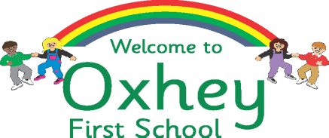
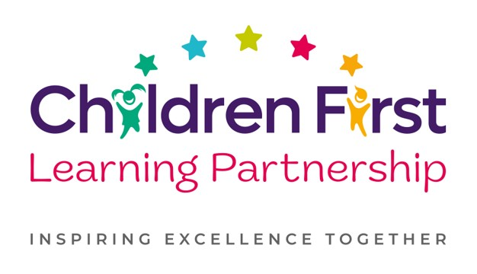

Oxhey First School
Pennine Way,
Biddulph
Staffordshire
ST8 7EB

Head teacher: Mrs L Jukes
Telephone 01782 513000
E mail office@oxhey.staffs.sch.uk
www.oxheyfirstschool.com

4th October 2023

Subject: Reception Health e-leaflet

Dear Parent/Carer

The Families’ Health and Wellbeing (0-19) Service is the local Health Visiting and School Nursing service. They offer support to schools and parents of children aged 0 to 19 years around lots of health-related topics to help children.
Please follow the link to an e-leaflet, which introduces your local School Nurses and shares some development and health information which parents/carers of reception aged children may find useful.

https://sway.office.com/SwdVfenfrCfB38jZ?ref=Link

The e-leaflet also contains a link to a contact form. This form is confidential, which means the answers you give will be returned to the Families’ Health and Wellbeing Service and will not be shared with our school.
The Families’ Health and Wellbeing Service can also be contacted through the Children and Families Health and Wellbeing Single Point of Access (CaFSPA), often referred to as the Hub, or their ChatHealth (text) services.

CaFSPA Freephone: 0808 178 0611
ChatHealth (cost of standard rate message) text: 07520 615 722

Kind Regards

Mrs L Jukes

Head teacher

