OXHEY FIRST SCHOOL
A HAPPY PLACE TO LEARN AND GROW

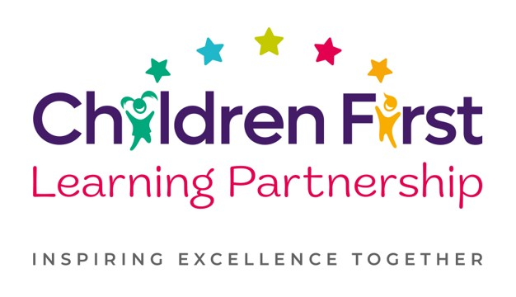
Oxhey First School
Pennine Way,
Biddulph
Staffordshire
ST8 7EB

Head teacher: Mrs L Jukes
Telephone 01782 513000
E mail office.oxh@cflptrust.co.uk
www.oxheyfirstschool.com

Dear Parents and Carers,

A special visit to Woodhouse Academy has been organised for the Y3 children. Woodhouse Academy have an amazing opportunity to showcase rocks from the Moon and Mars with us. This visit has been organised for all Y3 pupils on Tuesday 5th December 2023. During the visit, children will have the chance to explore these items and complete a moon-related science investigation.

We will be walking to Woodhouse at 9.00am in order to arrive promptly for a 9.30am start. Children will be returning to school before lunch time so normal dinner arrangements will apply. Due to the time of year, please ensure that your child has a warm coat and a hat/scarf/gloves if necessary.

Thank you for your ongoing support,

Mrs Holt, Mrs Nevitt and Miss Eccleston

_________________________________________________________________________________________________
Year 3 Woodhouse Science Workshop – Tuesday 5th December 2023

I consent to my child ___________________________________________ of class _______________ taking part in the above trip.

Signed: ________________________________________________________________

