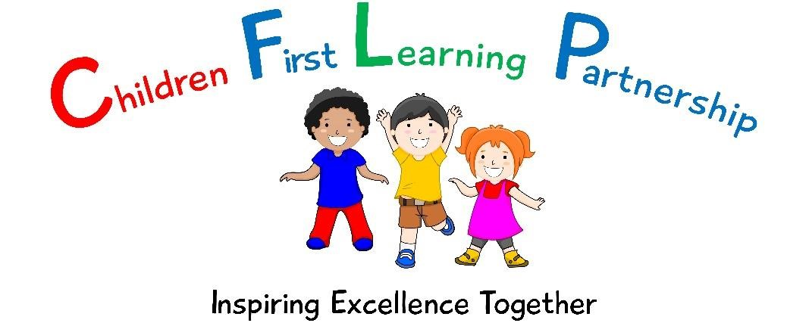
The Children First Learning Partnership
Charging and Remissions Policy
June 2023
(Version 4)

The Charging and Remissions Policy in respect of the Children First Learning Partnership has been discussed and adopted by the Directors Board
Chair of Board: Mrs N. Chell
Responsible Officer: CEO – Mrs A Rourke
Agreed and ratified by the Directors June 2023
To be reviewed: June 2024

Aim
The aim of this policy is to set out what charges will be levied for school activities, external lettings and extended school provision, what remissions will be implemented and the circumstances under which voluntary contributions will be requested from parents. Guidance is based on the Education Act 1996: Sections 449-462.

Responsibilities
The Board of Directors are responsible for determining the content of the policy and the head teacher for implementation. Any determinations with respect to individual parents will be considered jointly by the Executive Head Teacher/Headteacher and the Local Advisory.

Definitions
Community Facilities – activities which the Board of Directors do not feel is of direct educational benefit to children at the school
Extended school provision – provision of childcare outside the standard school day where it is optional as to whether the child attends
External Lettings – letting to an organisation other than the school
Remission – where a charge is not payable, either in full or in part
Sinking Fund – a reserve put aside over a number of years to pay for major maintenance or renewal costs

Prohibition of Charges
The Board of Directors recognise that the legislation prohibits charges for the following:

- education provided during school hours (including the supply of any materials, books, instruments or other equipment);
- education provided outside school hours if it is part of the National Curriculum, or part of a syllabus for a prescribed public examination that the pupil is being prepared for at the school, or part of religious education; • tuition for pupils learning to play musical instruments if the tuition is required as an essential part of the National Curriculum, or part of a syllabus for a prescribed public examination syllabus being followed by the pupil, or the first access to the Key Stage 2 Instrumental and Vocal Tuition Programme (Wider Opportunities);
- entry for a prescribed public examination, if the pupil has been prepared for it at the school;
- education provided on any trip that takes place during school hours;
- education provided on any trip that takes place outside school hours if it is part of the National Curriculum, or part of a syllabus for a prescribed public examination that the pupil is being prepared for at the school, or part of the school’s basic curriculum for religious education;
- Supply teachers to cover for those teachers who are absent from school accompanying pupils on a residential
trip;
- transporting registered pupils to or from the school premises, where the local education authority has a statutory obligation to provide transport;
- transporting registered pupils to other premises where the Board of Directors or local education authority has arranged for pupils to be educated;
- transport that enables a pupil to meet an examination requirement when he has been prepared for that examination at the school;
- transport provided in connection with an educational trip.

Charges
- board and lodging on residential visits
- school meals (excluding universal free school meals and free school meals Cost per meal £2.83 (September 2023 – July 2024)

- the proportionate costs for an individual child of activities wholly or mainly outside school hours (optional extras) to meet the costs for:

  - travel
  - materials & equipment
  - non-teaching staff costs iv. entrance fees
v. insurance costs

- individual or group tuition in the playing of a musical instrument

- re-sits for public examinations where no further preparation has been provided by the school

- costs of non-prescribed examinations where no further preparation has been provided by the school

- any other education, transport or examination fee unless charges are specifically prohibited

- breakages and replacements as a result of damages caused wilfully or negligently by pupils

- extra-curricular activities and school clubs

- Letting of the school premises or grounds

- Extended school care activities such as breakfast club, after school club, “wrap around nursery provision and community swimming.

Knypersley First School – Kidzone
7.30am – 8.45am | £4.65
3.15pm – 4.15pm | £3.85
3.15pm – 6.15pm | £7.65
10% discount on more than one child attending
Kingsfield First School – Kool Kids
7.30am – 8.45am | £5.20
3.15pm – 4.30pm | £3.80
3.15pm – 5.15pm | £7.10
3.15pm – 6pm | £9.30
10% discount on more than one child attending
The Reginald Mitchell Primary School - Spitfires
7.30am – 8.15am  - child  - children  - children  - children | £4.90  £9.35  £13.80  £18.40
After 8.15am Per child | £1.65
3.15pm – 4.15pm  1 child | £4.40
- children  - children  - children | £8.30  £12.25  £16.20
After 4.15pm  - child  - children  - children  - children | £9.30  £17.70  £26.00  £34.45
10% discount on more than one child attending
Oxhey First School – Tiger Club
7.30am – 8.45am | £6.00
3.15pm – 4.30pm | £3.85
3.15pm – 6pm | £8.20
10% discount on more than one child attending
Both morning & afternoon session | £12.00
Castlechurch – High Fliers
7.30am – 8.45am | £4.35
3.15pm – 4.30pm | £7.65
3.15pm – 5.30pm | £8.75
3.15pm – 6.00pm | £9.85
10% discount on more than one child attending
Wraparound charges – Nursery (£4.52 per hour) - lunchtime charges at cost
Reginald Mitchell | £13.56
Kingsfield | £13.56
Knypersley | £13.56
Oxhey | £13.56
Castlechurch | £13.56
Community swimming
Knypersley | £4.00 per adult
Other schools | £1,950 pa
External organisations | £50 per hour

- Charges for materials or ingredients where the pupils wish to have the finished product

- Cost of transport to take part in work experience

Consideration will also be given by the Board of Directors to:

- the proportion of the costs recovered where a charge is to be made;

- whether any remission is to extend beyond the statutory minimum;

- whether or not special consideration is to be given to hardship cases not contained within the exemptions and how this is to be determined;

- arrangements for education where the parents fail to pay the charge being levied by the school;

- the level of support from the school budget where the level of voluntary contributions is insufficient to fund the visit or journey;

- the maximum amount that can be used from the school’s budget to support community facilities is the amount of the school standards grant allocation;

- any charge for a pupil activity should not exceed the actual cost. If further funds need to be raised to help in hardship cases, this must be voluntary

- for lettings, the charge should at least cover the cost, including:
Services (heat & light)
Staffing (security, caretaking & cleaning)
Administration
Wear & tear (sinking fund)

This will be agreed on an individual case basis.

Remissions

Children whose parents are in receipt of the following support payments will, in addition to having a free school lunch entitlement, also be entitled to the remission of charges for board and lodging costs during residential school trips. The relevant support payments are:

- Income Support;

- Income Based Jobseeker’s Allowance;

- Income-related Employment and Support Allowance;

- Support under part VI of the Immigration and Asylum Act 1999;

- Child Tax Credit, where the parent is not entitled to Working Tax Credit and whose annual income (as assessed by HMRC) does not exceed £16,190;

- The guarantee element of State Pension Credit;

- Support under part VI of the Immigration and Asylum Act 1999;
- In receipt of the 4 week run on of working tax credit (this is where someone becomes unemployed or reduces their hours and so is no longer entitled to working tax credit but will continue to receive it for a further 4 weeks and is entitled to free meals during that time);
- Universal credit (provided you have an annual net earned household income of no more than £7,400
as assessed by earnings from up to three of your most recent assessment periods). Your net earned income is your household income after taxes and deductions and does not include income from Universal Credit or any other benefits you may receive.
Where the school is in receipt of pupil premium funding for individual pupils those families will be supported by the school to ensure all children access the full range of curriculum and extra curriculum opportunities on offer, in order to support both the personal and academic development of pupils. However, if any other families feel they are suffering hardship they are actively encouraged to make contact with the school to discuss this with the
Headteacher /Head of School/ Exec Headteacher. If the school feels it necessary, they will support such families or
arrange a payment plan where this may be helpful

Voluntary Contribution

Parents will be invited to make a voluntary contribution for the following:

- school trips and visits
- visiting specialists such as theatre groups, craft specialists and sports instructors.

The terms of any request made to parents will specify that the request for a voluntary contribution and in no way represents a charge. In addition, the following will be made clear to parents:

- that the contribution is genuinely voluntary and a parent is under no obligation to pay; and

- that registered pupils at the school will not be treated differently according to whether or not their parents have made any contribution in response to the request.

The costs of any optional extra undertaken by any pupil whose parents/guardians are unable to pay may not be included in the charge to other pupils but must be funded through the delegated budget, school fund or other fundraising. A £1 per child fee will be added to the cost of a trip to cover administration costs.

The responsibility for determining the level of voluntary contribution is delegated to the Executive Head teacher / Headteacher

Version Control:
Version | Date | Amendment | By
V2 | 07.06.2021 | Date of review- June 2021 and ratification changed to June  2022(Front cover) | CEO
V2 | 07.06.2021 | Page 3 Charges amended in line with NEF funding increase from £4.04 per hour to £4.10 per hour. | CEO
V2 | 07.06.2021 | Added: school meals (excluding universal free school meals and free school meals  Cost per meal £2.45 (September 2021- July 2022) | CEO
V2 | 07.06.2021 | Session charge amended in line with NEF hourly increase from  £12.12 to £12.30 for 3 hours | CEO
V3 | 30.06.2022 | School meal charge amended in line with SLA charge increase to £2.50 (September 2022 – July 2023) from £2.45 | CFO
V3 | 30.06.2022 | Session charge amended in line with NEF hourly increase from  £12.30 to £12.78 for 3 hours from Sept 2022 | CFO
V3 | 30.06.2022 | Added: Extended school care activities charges for Castlechurch High Fliers | CFO
V3 | 30.06.2022 | Added: Wraparound charges – Nursery charges for Castlechurch | CFO
V3 | 30.06.2022 | Knypersley swimming pool hire for other schools charge increase to £1,650 from £1500 | CFO
V3 | 30.06.2022 | Knypersley swimming pool hire for external organisation £30 per hour | CFO
V4 | 29.06.2023 | Date of review- June 2023 and ratification changed to June 2024 (Front cover) | CFO
V4 | 29.06.2023 | School meal charge amended in line with SLA charge increase to £2.83 per meal (September 2023 – July 2024) | CFO
V4 | 29.06.2023 | Nursery session charge amended in line with NEF hourly increase to £4.52 per hour / £13.56 per 3 hour session | CFO
V4 | 29.06.2023 | Extended school charges amended in line with Support Staff pay rise 9.42% | CFO
V4 | 29.06.2023 | Swimming charges amended in line with energy cost rise 50% for Saturday/Sunday hire (additional energy to heat pool outside school hours):  External organisations (Puddleducks Saturday/Sunday) £50 per hour  Swimming charges amended in line with Support Staff pay rise 9.42% and energy cost rise 15% (share of cost rise with swimming pool used within school hours):  Other schools £1,950 (increase £300)  Community baby and adult swimming £4.00 per adult | CFO
V4 | 29.06.2023 | Remissions criteria extended with  Income-related Employment and Support Allowance; | CFO

