OXHEY FIRST SCHOOL
A HAPPY PLACE TO LEARN AND GROW


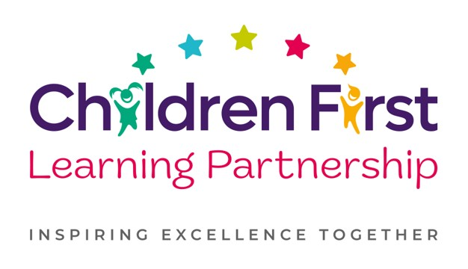
Oxhey First School
Pennine Way,
Biddulph
Staffordshire
ST8 7EB

Head teacher: Mrs L Jukes
Telephone 01782 513000
E mail office.oxh@cflptrust.co.uk
www.oxheyfirstschool.com

Dear parents and carers,

We are pleased to announce a return our egg-tastic Easter bingo event. This will be held on Wednesday 20th March 5pm-7pm. Tickets are £5 per person which includes entry and 3 games of bingo. To pre-order and pay for tickets and an optional intermission snack of a sausage roll (vegan option available) at an additional cost of £1 each, please complete the slip below and with the correct money in an envelope clearly marked with your child’s name & class put it in the box in the main reception.

On the night there will also be:
- Name the Easter bunny - £1 a go
- Football card to win Stoke City tickets - £1 a go
- Tuck shop and drinks
- Extra game of speed bingo and an extra game of Irish bingo which can be bought at half time at a £1 a game.

This is a very popular event and therefore tickets will be allocated on a first come - first served basis.

Many thanks
Oxhey First School PTFA

--------------------------------------------------------------------------------------------------------------------------------------

I would like .........tickets at £5 each for the Easter bingo on Wednesday 20th March at 5pm.

I would like......meat sausage rolls at £1 each (pre-order only). I would like .......vegan rolls at £1 each (pre-order only).

Child's name......................................................................class..........

I enclose £ ......to cover the cost of tickets and pre-ordered meat/vegan rolls.

