OXHEY FIRST SCHOOL
A HAPPY PLACE TO LEARN AND GROW


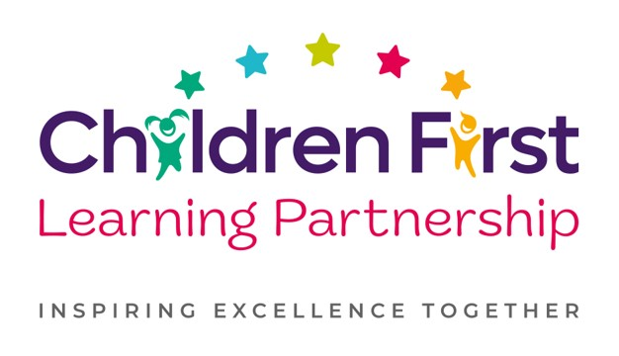
Oxhey First School
Pennine Way,
Biddulph
Staffordshire
ST8 7EB

Head teacher: Mrs L Jukes
Telephone 01782 513000
E mail office.oxh@cflptrust.co.uk
www.oxheyfirstschool.com

Dear Parents and Carers, 18.3.24

As a great follow-up from British Science Week, we have arranged a special visit to Woodhouse Academy to view their Science Fair! This has been organised for all KS2 pupils on Friday 22nd March 2024. During the visit, children will have the opportunity to view lots of different science projects and take part in some hands-on activities.

The children will have an early lunch on Friday but are still able to order a hot meal, should they wish to. We will be walking to Woodhouse Academy at 11.45am in order to arrive promptly for a 12.00pm start. We will return to Oxhey for afternoon lessons and normal end-of-day dismissal arrangements apply. Please ensure your child has a coat with them in school on Friday, should the weather be inclement.

Please sign and return the reply slip below if you consent to your child attending the visit.

Thank you for your ongoing support,

Miss Eccleston, Mrs Nevitt and Mrs Holt

_________________________________________________________________________________________________

KS2 Woodhouse Science Fair – Friday 22nd March 2024

I consent to my child ___________________________________________ of class _______________ taking part in the above visit.

Signed: ________________________________________________________________

