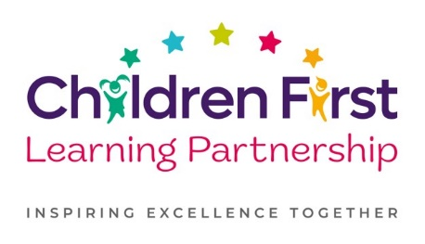

Dear Parent / carer,

Free School Meals and Pupil Premium

Your child may be eligible for Free School Meals.

If your child is eligible for Free School Meals and you register them for this, the school will also receive extra funding called Pupil Premium. We use this extra money to improve the educational provision and resources in school.

What is Pupil Premium funding?

Pupil Premium funding from the government is given to schools to help pupils reach their full potential. It is provided for pupils who:
- Are registered for Free School Meals
- Have been registered for Free School Meals at any point in the past 6 years
- Are, or have been, in care
- Have parents in the armed forces

School receives an extra £1,455 for every eligible pupil who is registered for Free School Meals even if your child is in Reception, Y1 & Y2. If your child is in Y3 or Y4 and you are eligible you would not have to pay for school meals.

You may be able to claim for Free School Meals if you claim for any of the following:
- Income Support
- Income Based Job Seekers Allowance
- Income Related Employment and Support Allowance
- Eligible for Child Tax Credit but not Working Tax Credit and the household income (as used by HMRC to assess tax credits) is not more that £16,190. Please note: anyone eligible for Working Tax Credit, or if you have a partner and they receive it, regardless of Income, you will not qualify
- The Guarantee element of State Pension Credit
- Support under part VI of the Immigration and Asylum Act 1999
- In receipt of the 4 week run on of working tax credit (this is where someone becomes unemployed or reduces their hours and so is no longer entitled to working tax credit but will continue to receive it for a further 4 weeks and is entitled to free meals during that time)
- Universal credit (provided you have an annual net earned household income of no more than £7,400 as assessed by earnings from up to three of your most recent assessment periods). Your net earned income is your household income after taxes and deductions and does not include income from Universal Credit or any other benefits you may receive.

If you are in receipt of any of the above please complete the details on the back of this letter and return to the school office.
You can also apply online:
https://www.staffordshire.gov.uk/Education/Educational-awards-benefits/FreeSchoolMeals/Apply-online.aspx

If you have queries please do not hesitate to contact us.

Full name of child

Child’s date of birth

Parent/claimant full name

Parent date of birth

Parent National Insurance number

Which of the allowances overleaf do you claim?

Parent email address

Parent signature

I agree that you will use the information I have provided to process my claim for free school meals to verify my initial, and ongoing entitlement and that you may contact other sources as allowed by law to confirm this. I also agree that should my initial application be refused further checks will be periodically automatically made for 30 days to see if I later become entitled.*
I agree that you can inform the school(s) attended by my child(ren) of their initial and ongoing entitlement to free school meals. I also understand that the results of any eligibility check may also be used to assess entitlement to receive free travel to school or eligibility of the Early Years Pupil Premium for my child’s nursery (where appropriate), or to create a claim for free school meals for a sibling at a later date.*
I agree that the information provided on this application form will be used to ensure that the council’s records are correct and may also be shared with other agencies and service providers to ensure that my family receives an appropriate service. The full Data Protection statement can be found at Your Data.*
I agree that the information I have provided is true to the best of my knowledge, and understand that any false or deliberately misleading information provided on this form and/or supporting papers may render this application invalid and could lead to the withdrawal of free school meals.*
I agree that that the Free School Meals Entitlement Service can contact any relevant agencies in order to validate this application.

