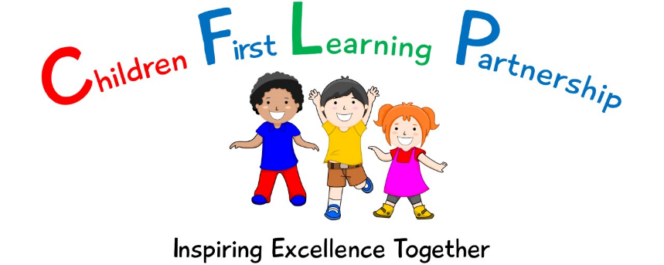
Core Offer & Graduated Response
for those children with SEMH needs
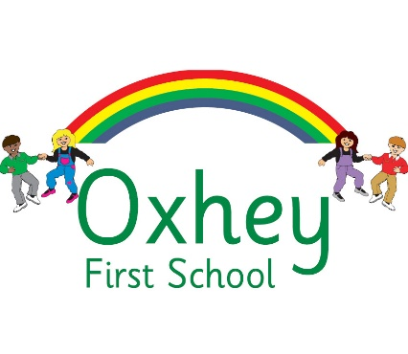
September 2023

Excellent behaviour is a minimum expectation for all. Everyone is expected to maintain the highest standards of personal conduct, to accept responsibility for their behaviour and encourage others to do the same. We aim to create a culture of exceptionally good behaviour for learning which lays down the blueprint for positive behaviour for life. We encourage our learners to be ambitious for themselves and for others, as we support and challenge them in their learning journey. Staff, children, governors and parents recognise the need for an effective, uncomplicated and consistent approach to positive behaviour in order for high quality teaching and learning to take place. As part of our commitment to this, we have reviewed our behaviour policy and simplified our school rules to enable our whole school community to understand, embrace and remember them. All behaviour in school is underpinned by our three school rules:

- BE SAFE
- BE RESPECTFUL
- BE READY

We want our learners to be safe and feel safe; safe as they move around school, safe inside and outside the school building which includes being safe on school trips and staying safe online. We want our children to know who they can turn to for advice when they are worried or concerned, within school and outside of school. We aim to build a school community of people who protect not only our own safety but a community who take the time and care to look out for one another.
We want our learners to be respectful; to treat others fairly, to develop mutual respect alongside tolerance, patience and understanding, to listen when others speak, to respect others’ opinions, to use and show good manners and to respect class resources and the school environment. Ultimately, we aim to all work together to promote and develop strong, healthy relationships in school and within the local community.
We want our learners to be ready; ready to work and learn to their full potential by always doing their very best, ready to listen, ready to help, ready to act for a friend or neighbour in need, ready to lead, ready to give and forgive, ready to have fun and enjoy time in school.
‘A happy place to learn and grow’
This is the Oxhey way.

- A member of staff will meet and greet every child, every morning.
- There will be a consistency that ripples through every interaction on behaviour from all adults in school.
- All adults in school will model positive behaviours and show a real commitment to building positive relationships; remaining calm and using first attention to best behaviour, praising those who are demonstrating good behaviour and never ignoring or walking past children who are not following our three school rules.
- We will provide a curriculum which explicitly explores and defines what good behaviours, relationships and interactions look like within the school environment and beyond.
- We will promote and celebrate specific behaviours (social and/or learning behaviours) through the ‘Happy place to learn and grow’ motto.
- Children who go ‘over and above’ with their learning or their behaviour will be recognised in our weekly celebration assemblies through our celebration award.
- All adults in school will engage in reflective dialogue with learners, using the given scripts. When needed, restorative conversations will be held with individuals in a quiet space away from others.
- When necessary, pupils who persistently struggle to self-regulate against our school rules of safe, respectful and ready, are supported through a variety of strategies, interventions and external agencies.
- Where monitoring shows a pupil displays more serious or regularly repeated negative behaviours, a range of communication between SEND Leaders, Senior Leaders, parents and external agencies with take place as demonstrated in this SEMH Graduated Response
Behaviour Ladder | Behaviour expectation – rewards and sanctions
Above and Beyond | Continuously excelling and keen to learn more!  A visit to the Headteacher to choose a prize from the Golden Prize Box, a Headteacher Award sticker and a text message to parents/carers celebrating this achievement.
Flying High | Achieving something new for the first time and standing out with super effort.  Silver Certificate Award
Keep it Going | Continuing to do the right thing and showing real perseverance with their learning.  Bronze Sticker Award
Good to Go! | All children begin each day on Green and show they are doing the right thing and following the school rules. Being fully engaged in their learning.  Classroom rewards – stickers, house points etc.
Stop and Think | Low level disruption, and not following the school rules.  A warning is given and a discussion had to support in getting back on to green.
Take a Moment | Behaviour not corrected, and continuing to show low level disruption. Children showing disrespect to children or staff.  A further discussion will be had and thinking time in another part of the classroom is given to support a prompt change to more positive behaviour.
Time Out | Hurting others or showing aggressive behaviours or damaging school property.  Children moved to another classroom and spoken to by a member of SLT if required. Parents are informed and the behaviour is recorded on Arbor. Restorative practice implemented.

At the beginning of the school year and throughout the year, all staff work hard to reinforce our three school rules. Throughout the school day, pupils will be reminded of the three school rules through either direct or indirect conversations about whether behaviour is ‘ready, respectful and/or safe’.
Our approach to creating a positive ethos within school is to treat children positively, praising them, offering encouragement and acknowledging their achievements. We will ensure that children know that their effort, achievement and good behaviour is recognised and valued through a range of classroom and whole school strategies, see below:-

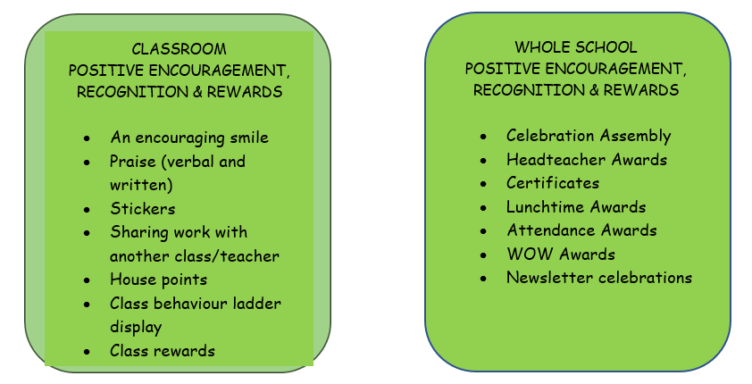

What all pupils should be getting: (The Oxhey Way)

Quality First Teaching/Whole Class Approach:
- Assemblies to explore Trust/School Values CHILDREN
- Adult’s desire to have an in-depth knowledge of the class needs and backgrounds in order to develop emotional currency within the classroom
- Create a relationally consistent and positive learning environment and atmosphere based on mutual respect
- Exploration of collaborative class/school rules which are displayed, referred to regularly and used to praise correct behaviours
- Adults and children have high expectations for learning behaviours and involvement, incorporating TIGER Learning principles
- Individualised praise for correct behaviours to support first attention being given to best conduct
- Clear and consistent routines embedded and visually displayed for the class
- Pinch points identified and routines used to minimise
- Class visual Behaviour Tracker which allows for positive and negative movement. Praise in public, Reprimand in private (PIP, RIP)
- Adults use structured interventions (Scripts) to remind children of expectations and shared rules
- Use of class visual emotion board displaying a range of emotions that have been introduced/explored by the children
- Access to visual toolkits, devised and discussed with pupils to support with the self-regulation of difficult emotions and behaviours
- Access to class worry station to ask for help/time/access to adults
- Access to playground buddies/mentors and pupil leaders for peer support
- Circle times
- PSHRE curriculum

 | Reasonable Adjustments | Intervention | SEN Support | SEN Support/EHC
Core offer | - Academic Assessment analysis – is the child able to access the curriculum? Are barriers to learning the root cause?  - Individual discussion with child – what are the trigger points for negative learning behaviours  - Individual behaviour tracker introduced  - Positive reward chart developed based on information gained from discussion  - Increased communication with home through texts, emails, informal catch ups  - Log any major behaviour incidents on Arbor with actions  - Reasonable adjustments made around trigger points – cloakroom/playtime/lunchtime/lining up/PPA/drop off & collection  - Good communication and shared expectations from all school staff  - DSL discussions and report analysis | - ABC sheets to be completed by school staff after incidents  - Behaviour for learning classroom audit completed by SENCo and provide recommendations  - Language assessment completed – BPVS/ Wellcomm/Speakwrite  - Meeting with parents to discuss the child’s emotional needs and behaviours  - Targeted Strategy Plan (TSP) written with pupil (if appropriate) SENCo, parents and class teacher signed by all parties  - Plan to be shared with all relevant adults including reasonable adjustments, rewards and sanctions to ensure consistency  - Complete Parent/teacher CFLP SDQs to gain a baseline and direction for intervention – analysed by SENCo  - Provide Nurture/Time to talk/CFLP interventions to support emotional literacy  - Complete Parent/Teacher CFLP SDQ to measure impact of intervention – analysed by SENCo  - Log major behaviour incidents on Arbor with actions  - ABC incident review to be completed and analysed by SENCo  - Refer to Trailblazers  - DSL discussions and report analysis | - Child added to the SEN register as SEN support  - SENCo to complete CFLP timed observation and provide recommendations  - Review Targeted Strategy Plan (TSP)  - Strategies plan to be written by all parties and include lessons learned from previous plans, recommendation from times observation and intervention organised  - Start Assess Plan Do Review process of strategies plan  - Refer to outside agencies for support:  Action for children, Dove, CAMHS, SAL, Early Help  - Log major behaviour incidents on Arbor with actions  - ABC incident review to be completed and analysed by SENCo  - Classroom staff to complete CFLP EIBC daily logs and analysed by SENCo  - Refer to CFLP SEND Hub for additional support and discussions | - Refer to SEND or Inclusion HUB to seek further outside agency support  - Refer to Educational Psychologist  - Outside agency reports scrutinised and recommendations put into practice and trialled.  - Evidence gathered of recommendations and interventions  - Log major behaviour incidents on Arbor with actions  - ABC incident review to be completed and analysed  - Complete Classroom staff to complete CFLP EIBC daily logs and analysed by SENCo  - Completed CFLP timed observation and review recommendations  - Consideration of Reduced timetable Plan and notify LA  - AEN funding application  - EHC application
Responsibility | - Class teacher  - DSL/DDSL | - Class teacher  - SENCo  - DSL/DDSL | - Class teacher  - SENCo  - CFLP SEND Hub  - DSL/DDSL | - Class teacher  - SENCo  - SEND Hub  - LA
Communication | - Telephone call  - Additional communication with parents  - Log on Communication & Notes on Arbor | - Meeting with parents  - Upload TSP and communication on Arbor  - Incidents/ABC to be analysed and trends highlighted | - Meeting with parents  - SEN Support on Arbor  - Upload TSP and communication onto Arbor  - Referrals uploaded on Arbor  - Intervention records analysed and reviewed  - Incidents/ABC to be analysed and trends highlighted | - External agency referral & reports – uploaded to Arbor Recommendations noted on paperwork/into practise  - Intervention records analysed and reviewed  - Incidents/ABC to be analysed and trends highlighted
SEMH

Year groups | Reasonable Adjustments | Intervention | SEN Support | SEN Support/EHC
YR

Y1
Y2
Y3
Y4
Y5

Y6

