OXHEY FIRST SCHOOL
A HAPPY PLACE TO LEARN AND GROW

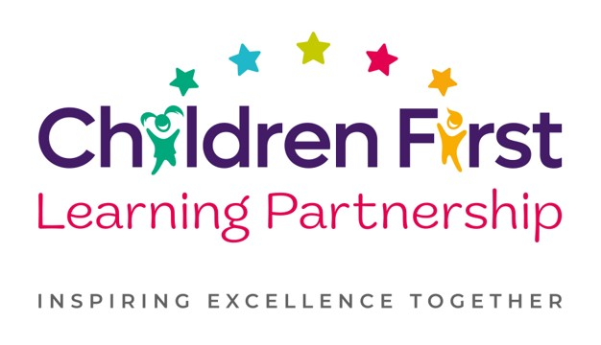
Oxhey First School
Pennine Way,
Biddulph
Staffordshire
ST8 7EB

Head teacher: Mrs L Jukes
Telephone 01782 513000
E mail office.oxh@cflptrust.co.uk
www.oxheyfirstschool.com

04.07.24
Year 4 Olivia Video Recording

Dear Parents and Carers,

We will be video recording the afternoon performance of Olivia on Wednesday 10th July. This year, the recording will be sent to all consenting Year 4 parents via a secure link to your email address and will be made available free of charge, as a lovely keepsake.

We require parental consent for the recording to take place, which should be provided on the reply slip below and returned to school by Monday 8th July.

Please do not hesitate to contact us should you have any questions or concerns.

Many thanks in advance,

The Key Stage 2 Team

_______________________________________________________________________________________

Year 4 Olivia Recording Consent 2024

I consent to my child ______________________________________________ class ________

appearing in the recoding of Olivia! On Wednesday 10th March. I understand this will be shared with consenting parents via a secure link.

Signed _________________________________________

