OXHEY FIRST SCHOOL
A HAPPY PLACE TO LEARN AND GROW


Oxhey First School
Pennine Way,
Biddulph
Staffordshire
ST8 7EB

Head teacher: Mrs L Jukes
Telephone 01782 513000
E mail office.oxh@cflptrust.co.uk
www.oxheyfirstschool.com

July 2024

Dear Parents and Carers,
Following on from our achievements and success during this academic year, I am writing to inform you of a dynamic and innovative change to the future leadership structure at Oxhey First.
In conjunction with the CEO and the Directors, all members of Oxhey’s Local Advisory Board have agreed that an Executive Headteacher, a Head of School and an Assistant Headteacher will form the new leadership team from September.
The decision was made after careful consideration of the benefits it will afford us, to enhance and positively develop the provision, learning and wider experiences at Oxhey.
This new structure will ensure the continued quality of teaching and strong leadership we expect at Oxhey by retaining knowledgeable staff, the sharing of best practice across schools in the Children First Learning Partnership, curriculum development and efficient resource management.
We have already seen the benefits of working collaboratively; we have been able to deliver a newly re-designed and developed outdoor area, ICT equipment for pupils, a timber trail, the EYFS play area, a new roof on the annexe building, non-core specific curriculum resources and achieved ‘outstanding’ in our recent Ofsted inspection.
Following the recruitment process I am delighted to share that the Executive Headteacher will be Mrs L Jukes and the Head of School will be Mrs E Cooper. Mrs Cooper will be supported by Mrs E Holt, who has been appointed as the new Assistant Headteacher.
Mrs Jukes has been appointed to become the Executive Head of several schools within the Children First Learning Partnership. She will oversee the strategic leadership and development of those schools, which includes Oxhey, supporting and developing leadership capacity. She will ensure policies and procedures such as safeguarding are in place and that staff development and school priorities are ambitious, well embedded and have a positive impact for all children and their families. She will attend Oxhey regularly and maintain the strong relationships she has developed with all stakeholders as part of her new strategic leadership role.

Mrs E Cooper has been appointed as our Head of School - this will mean that on an operational day-to-day basis, she will lead the school and her senior leadership team to ensure agreed priorities are addressed, policies implemented, routines are consistent and standards of teaching and learning remain high. She will make sure that support for our pupils, staff and parents is provided as required. May I take this opportunity to congratulate Mrs Cooper on her appointment and thank her for her work as Assistant Head supporting Mrs Jukes. I am sure you will all agree she has done this with professionalism and integrity.
With the promotion of Mrs E Cooper, we have also recruited Mrs E Holt to be our new Assistant Head and from our interview process it is very evident that Mrs E Holt has the knowledge and skills to support Mrs Cooper extremely effectively. Congratulations to Mrs E Holt.

Oxhey First School

Leadership Structure September 2024

Mrs Lorraine Jukes  Executive Headteacher | Mrs Emily Cooper  Head of School | Mrs Elizabeth Holt  Assistant Headteacher
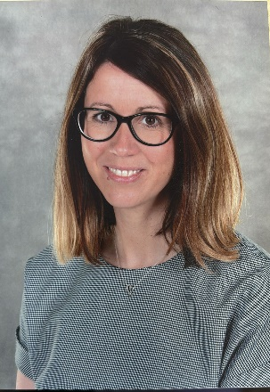 |  | 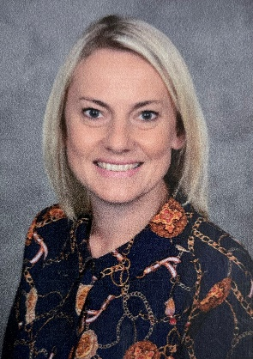

We are confident that our new leadership structure will be extremely capable of not only sustaining the excellent levels of provision here at Oxhey, but develop elements even further over time. All three staff have already begun to take on aspects of their new roles and Mrs Rourke, CEO, has been providing a package of training and development to ensure this is achievable.

If you have any questions regarding this letter, please do not hesitate to contact the school office. Meanwhile, may I thank you for your continued support and may I take this opportunity to wish Mrs Jukes, Mrs Cooper and Mrs Holt all the very best of luck in their new roles.

Yours sincerely,
Mrs Wendy Parrott
Chair of the Local Advisory Board

