OXHEY FIRST SCHOOL
A HAPPY PLACE TO LEARN AND GROW

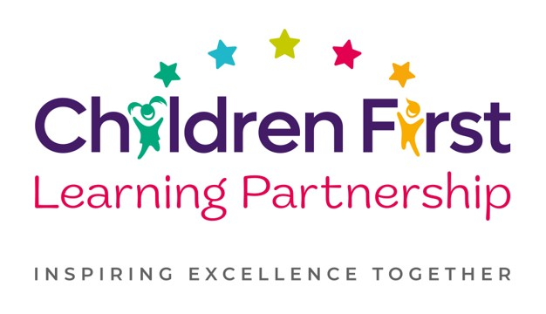
Oxhey First School
Pennine Way,
Biddulph
Staffordshire
ST8 7EB

Head teacher: Mrs L Jukes
Telephone 01782 513000
E mail office.oxh@cflptrust.co.uk
www.oxheyfirstschool.com

Dear Parents and Carers,

Please find attached your tickets for the end of Year 4 show; ‘Olivia!’ on Wednesday 10th July at 1.30pm and Thursday 11th July at 6pm.
We have provided each child with 2 tickets for the afternoon performance and 2 tickets for the evening performance. In order to comply with health and safety and to ensure there is no overcrowding, unfortunately we are unable to provide any additional tickets. Therefore, only 2 people per child may attend each show.

Please note that following the evening show, we will be presenting our end of year awards and trophies and providing some light refreshments for you to enjoy. Therefore, we recommend parents attend the evening performance where possible.

Thank you for your continued support, we look forward to seeing you then!

Yours Sincerely,

The KS2 Team

