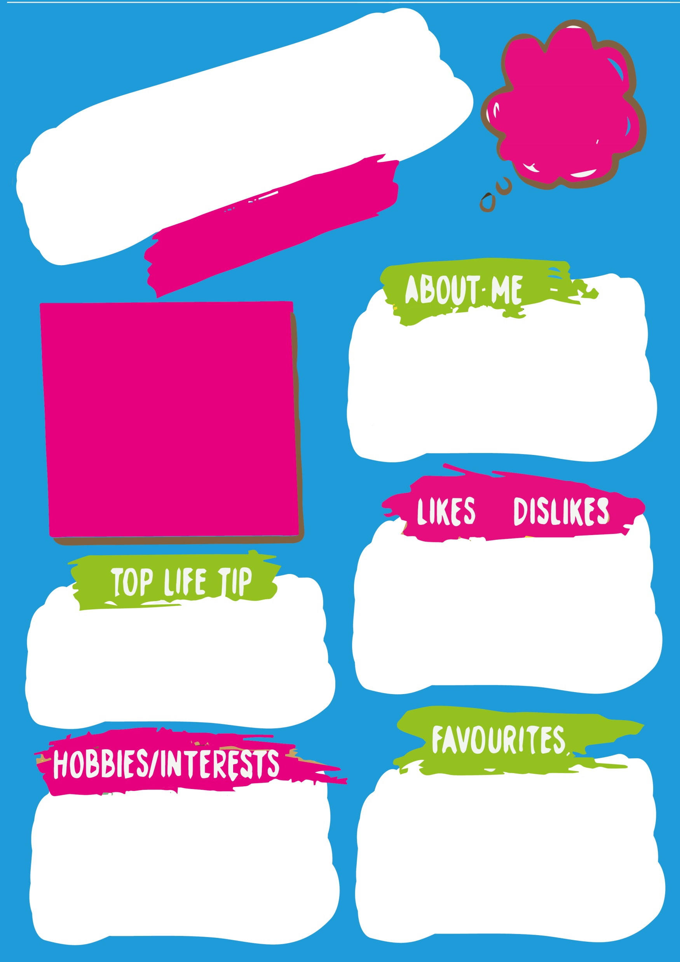

Failing is not a bad thing it is just a

**F**irst

**A**ttempt

**I**n

**L**earning

I love spending time with my 2 children and my mum. I enjoy helping people, making new friends and sharing my smile. I use these skills in my work in schools.

Chocolate

Laughing

Nature

Singing

My favourite colour is blue, but I love all colour so maybe rainbow.

My favourite animal is a penguin.

I don’t get a lot of time for hobbies but when I do get time to myself I enjoy massages, music gigs and spending time with friends.

Name: Kathryn Kathryn

Education Mental Health Practitioner (EMHP)

Nothing is impossible the word itself says ‘I’m possible’ Audrey Hepburn

The rain

Conflict

Horror films

Football

