OXHEY FIRST SCHOOL
A HAPPY PLACE TO LEARN AND GROW

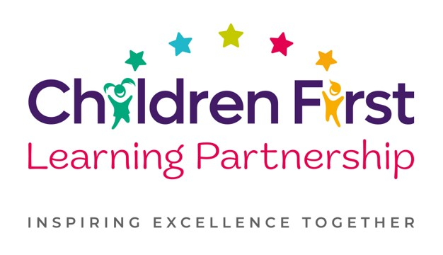
Oxhey First School
Pennine Way,
Biddulph
Staffordshire
ST8 7EB

Executive Headteacher: Mrs L Jukes
Head of School: Mrs E.Cooper
Telephone 01782 513000
E mail office.oxh@cflptrust.co.uk
www.oxheyfirstschool.com

Dear Parents/Carers, 5.9.24

I am delighted to inform you that your child has expressed an interest in joining the school choir and I am writing with exciting news for 2025. Oxhey First School will perform as part of the Children First Learning Partnership at the Co op Live Arena in Manchester on Thursday 6th February 2025 at the Young Voices Foundation Arena Concert. The arena will be filled with choirs from many other schools, all singing the same tracks together, along with professional musicians, dancers and celebrities from the music industry. This will be a huge celebratory event and an amazing experience that pupils and parents will remember fondly.

I will share details about the songs and full arrangements for the event itself in due course, but for now, I am simply enquiring if your child will be participating. As we are performing as a Multi Academy Trust, numbers per school are limited this year. Please therefore ensure your slip, located at the bottom of this letter, is returned as soon as possible to secure your child’s place.

The following information is about rehearsals and arrangements for the day. The choir rehearses once a week for approximately 30 minutes. This will be on a Thursday lunchtime at 12:00p.m. There will be an expectation for choir members to attend all rehearsals and to practise the songs at home. The day of the concert is quite long, with an afternoon rehearsal at 1:30pm, followed by a packed-tea in the arena and then the concert itself, which finishes around 9:30pm, arriving back at school around 10:45pm. Audience tickets cost approximately £20 each (children performing do not require a ticket). For any further information and testimonials of previous events, please visit the young voices website at www.youngvoices.co.uk.

The children are very excited to be given this opportunity so I hope as many as possible will be able to attend. Please ensure reply slips are returned to me directly or the office by Friday 20th September.
Many thanks for your continued support

Mrs E. Holt
Assistant Headteacher
OXHEY FIRST SCHOOL – YOUNG VOICES CHOIR EVENT 2025

I, the parent/carer of _______________________________________________ give permission/ do not give permission

for my child to attend the Young Voices concert on Thursday 6th February 2025

Signed _________________________________________________________________

