OXHEY FIRST SCHOOL
A HAPPY PLACE TO LEARN AND GROW

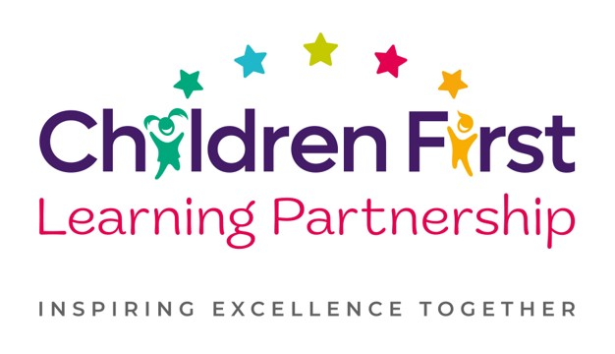
Oxhey First School
Pennine Way,
Biddulph
Staffordshire
ST8 7EB

Executive Head teacher: Mrs L Jukes
Telephone 01782 513000
E mail office.oxh@cflptrust.co.uk
www.oxheyfirstschool.com

20.3.2025
Dear parents and carers,

We are pleased to announce the return of our egg-tastic Easter bingo event! This will be held on Thursday 10th April 5pm-7pm. Tickets are £5 per person which includes entry, 3 games of bingo and two bonus rounds of Irish and Speed bingo! An optional intermission snack of a sausage roll (vegan option available) will also be available at an additional cost of £1 each. To pre-order sausage rolls and reserve tickets, please complete the slip below and return it with the correct money in an envelope, clearly marked with your child’s name & class. This may be handed to your child’s teacher or placed in the box in the main reception.

On the night there will also be:
- Name the Easter bunny – 50p a go
- Tuck shop
- Bar selling soft drinks, prosecco and bottles of lager

Please note, this is a very popular event. Tickets are limited to ensure we are compliant with health and safety regulations in the hall and therefore everyone attending requires a ticket. Many thanks for your cooperation with this matter.

We look forward to another egg-siting event!

Best wishes,
Oxhey First School PTFA

--------------------------------------------------------------------------------------------------------------------------------------
PTFA Easter Bingo Event

I would like .........tickets at £5 each for the Easter bingo on Thursday 10th April at 5pm.

I would like......meat sausage rolls at £1 each (pre-order only). I would like .......vegan rolls at £1 each (pre-order only).

Child's name......................................................................class..........

I enclose £ ......to cover the cost of tickets and pre-ordered meat/vegan rolls.

