

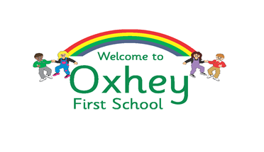
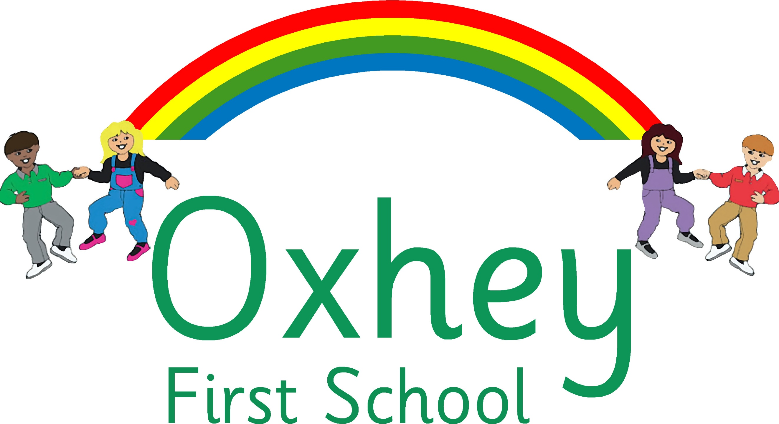
A Happy Place to Learn and Grow

Positive Behaviour Policy

V.3 June 2026
June 2027 or earlier if required
To be reviewed:
29.06.2026
Agreed and ratified by the Local Advisory Board on:
Oxhey Head of School – Mrs. K Proffitt

Responsible Officer:
Mrs. W Parrott
Chair of Local Advisory Board:

The Behaviour Policy in respect of the Children First Learning Partnership has been discussed and adopted by the Local Advisory Board.
*This policy is based upon the Classroom Culture Crisis Prevention Training.

Intent
Oxhey First School is a happy, vibrant school where diversity and individuality are celebrated. We are passionate in our pursuit of excellence in all aspects of school life. We nurture and inspire children to develop confidence, independence and resilience in an environment where efforts are valued and all children flourish. Throughout their time with us, pupils are empowered to gain the skills and knowledge to become citizens of the future. On a day-to-day basis our school promotes our Trust’s shared values of:
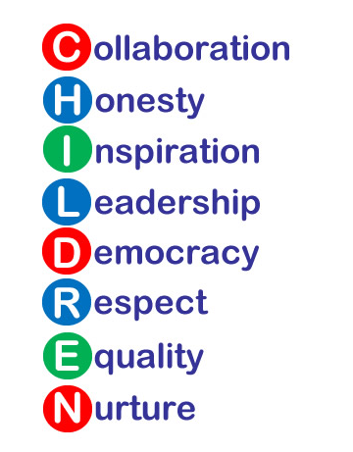

Excellent behaviour is a minimum expectation for all. Everyone is expected to maintain the highest standards of personal conduct, to accept responsibility for their behaviour and encourage others to do the same. We aim to create a culture of exceptional behaviour for learning which lays down the blueprint for positive behaviour for life. We encourage our learners to be ambitious for themselves and for others, as we support and challenge them in their learning journey. Staff, children, governors and parents recognise the need for an effective, uncomplicated and consistent approach to positive behaviour in order for high quality teaching and learning to take place. As part of our commitment to this, we have reviewed our behaviour policy and simplified our school rules to enable our whole school community to understand, embrace and remember them. All behaviour in school is underpinned by our three golden rules:

- BE SAFE
- BE RESPECTFUL
- BE READY

We want our learners to be safe and feel safe; safe as they move around school, safe inside and outside the school building which includes being safe on school trips and staying safe online. We want our children to know who they can turn to for advice when they are worried or concerned, within school and outside of school. We aim to build a school community of people who protect not only our own safety but a community who take the time and care to look out for one another.

We want our learners to be respectful; to treat others fairly, to develop mutual respect alongside tolerance, patience and understanding, to listen when others speak, to respect others’ opinions, to use and show good manners and to respect class resources and the school environment. Ultimately, we aim to all work together to promote and develop strong, healthy relationships in school and within the local community.

We want our learners to be ready; ready to work and learn to their full potential by always doing their very best, ready to listen, ready to help, ready to act for a friend or neighbour in need, ready to lead, ready to give and forgive, ready to have fun and enjoy time in school.

Implementation

The Oxhey Way - ‘A Happy Place to Learn and Grow’

- A member of staff will meet and greet every child, every morning.
- There will be a consistency that ripples through every interaction on behaviour from all adults in school.
- All adults in school will model positive behaviours and show a real commitment to building positive relationships; remaining calm and using first attention to best behaviour, praising those who are demonstrating expected behaviours and never ignoring or walking past children who are not following our three school rules.
- Provides a curriculum which explicitly explores and defines what our expected behaviour, relationships and interactions look like within the school environment and beyond.
- We will promote and celebrate specific behaviours (social and/or learning behaviours) through our school motto, TIGER learning and our shared Trust values.
- Children who go over and above with their learning or their behaviour will be recognised in our weekly celebration assemblies through our ‘Star of the Week’ and ‘TIGER Learner’ awards.
- All adults in school will engage in reflective dialogue with learners, using the given scripts. When needed, restorative conversations will be held with individuals in a quiet space away from others.
- When necessary, pupils in school who persistently struggle to self-regulate are supported through a variety of strategies, interventions and external agencies.
- Where monitoring shows a pupil displays more serious or regular repeated challenging behaviours, a range of communication between SEND Leaders, Senior Leaders, parents and external agencies with take place as demonstrated in the school’s SEMH Graduated Response.

At the beginning of the school year and throughout the year, all staff work hard to reinforce our three school rules. Throughout the school day, pupils will be reminded of the three golden rules through either direct or indirect conversations about whether behaviour is ‘safe, respectful and/or ready’.
We foster a positive ethos by treating children with kindness and encouragement, praising their efforts and acknowledging and celebrating their achievements and success. We will ensure that children know that their effort, achievement and behaviour are recognised and valued through a range of classroom and whole school strategies, see below:

CLASSROOM
POSITIVE ENCOURAGEMENT, RECOGNITION & REWARDS

- An encouraging smile
- Praise (verbal and written)
- Stickers
- Sharing work with another class/teacher
- House points
- Positive Behaviour Ladder
- Class rewards
WHOLE SCHOOL
POSITIVE ENCOURAGEMENT, RECOGNITION & REWARDS

- Celebration Assembly
- Headteacher Awards
- Text Message Home
- Certificates and Praise Notes
- Lunchtime stickers
- Attendance Bear
- WOW Awards
- Newsletter celebrations

Strategies to Manage Behaviour
Children are held responsible for their own behaviour. Staff will address and manage behaviour using the positive behaviour ladder and behaviour windscreen. These are designed to give our children every opportunity to modify and change their behaviour for the better. Staff take individual needs into account and give children time to reflect.

School Behaviour Logs & Monitoring
All ‘red behaviours’ are formally recorded. Our school has a confidential behaviour log on our Arbor Information System. These are written records of interactions and conversations concerning behaviour. The log is dated and includes relevant information and action taken. Incidents of proven bullying and racism incidents are always reported directly to the Head of School or Assistant Headteacher. Weekly reports are generated by Arbor and are analysed thoroughly and discussed regularly by Senior Leaders. Any subsequent actions from these meetings would be in line with our school SEMH graduated response. These reports are also discussed termly within our Safeguarding Link Governor meetings.

Positive Behaviour Ladder
The following behaviour ladder is displayed in all classrooms:

Behaviour Ladder | Expectation and Rewards
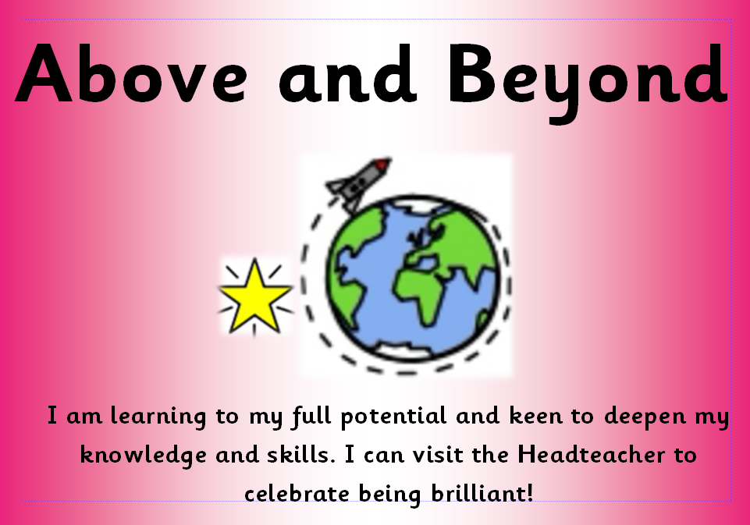 | I am learning to my full potential and keen to deepen my knowledge and skills. I can visit the Headteacher to celebrate being brilliant!  A Headteacher’s Award (prize, certificate and sticker) and a text message to parents/carers celebrating this achievement.
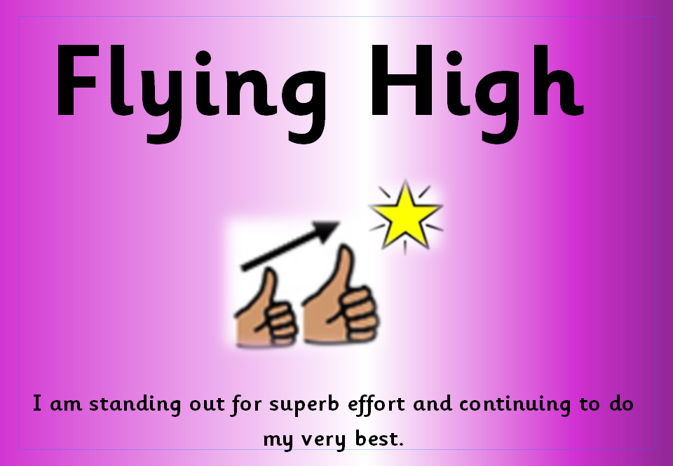 | I am standing out for superb effort and continuing to do my very best.  Silver Certificate Award
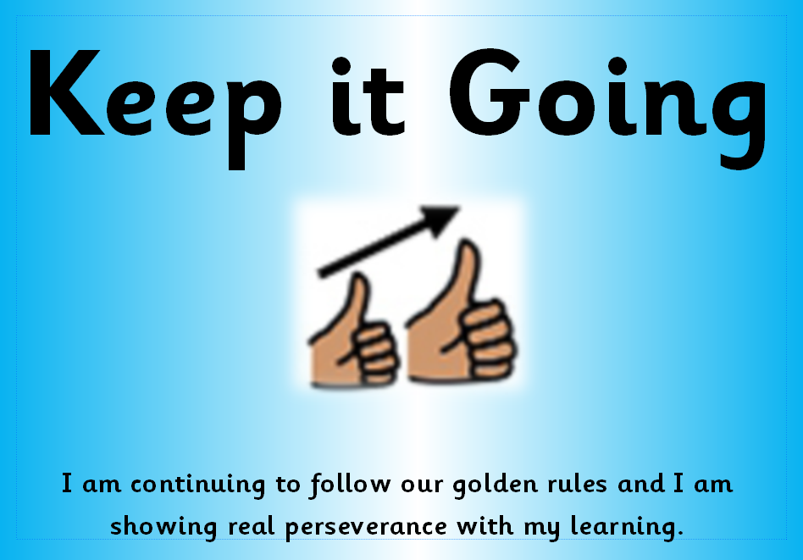 | I am continuing to follow our golden rules and I am showing real perseverance with my learning.  Bronze Sticker Award
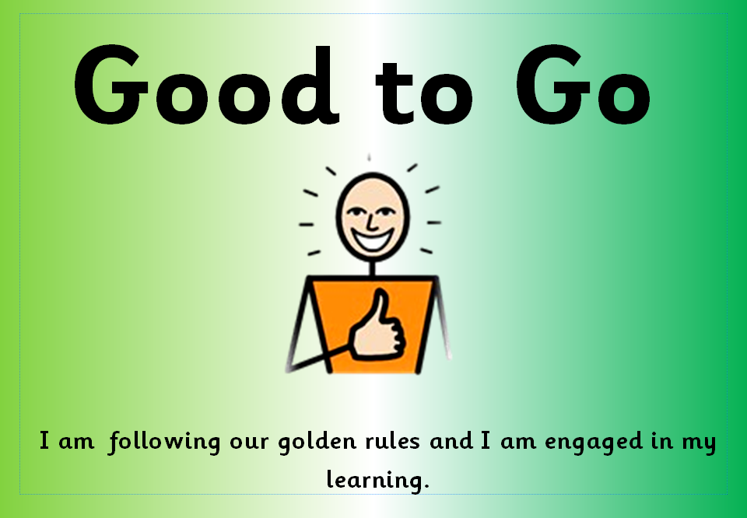 | I am following our golden rules and I am engaged in my learning.  All children begin each day on Green. Classroom rewards include verbal and written praise, stickers, house points, sharing work with another class etc.

Positive Behaviour Steps
As part of our commitment to quality first teaching, staff ensure frequent, consistent encouragement and reminders of our core expectations and golden rules throughout the school day. When praise, reminders and encouragement are not sufficient to enable a child to follow our golden rules and remain engaged in their learning (Good to Go - Green), a separate resource (see our behaviour windscreen below) is used for next steps. This resource is prominent in all classrooms however, it is separate from the behaviour ladder. It is consistently used by all staff to encourage a calm, consistent and kind approach and promotes the time needed for restorative conversations. We believe it is these moments and conversations that lie at the heart of positive behaviour and relationship management.
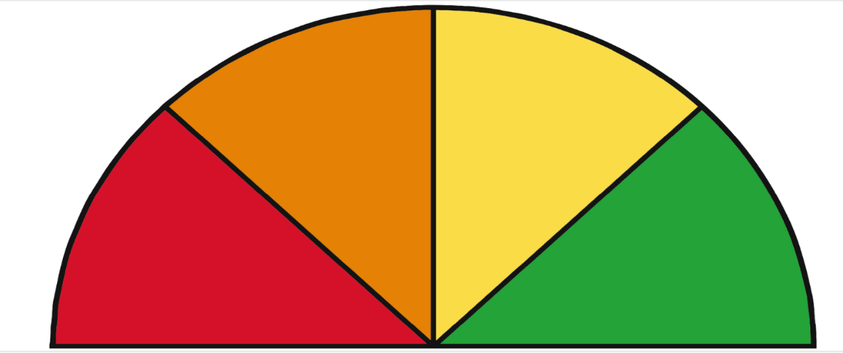
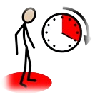


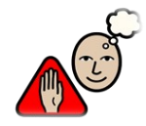
Stop and Think
Time to Reflect
Warning - Stay Good to Go!
Time Out

 | STEPS | ACTIONS
1 |   Frequent Encouragement and Reminders | As part of our commitment to quality first teaching and non-negotiables, staff ensure frequent, consistent encouragement and reminders of our golden rules and expectations throughout every lesson, during key transitions and throughout the school day.
2 | Warning  Stay Good to Go! | Use our warning script, delivered discreetly and privately where possible using the behaviour windscreen, as a final reminder of our rules; be safe, be respectful, be ready. Repeat reminders if necessary to ensure a clear message is given to the child. Deescalate and decelerate where reasonable. Recognise and praise positive choices and behaviour as a result of the warning.
3 | 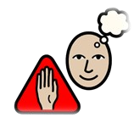  Stop and Think | If the warning is not heeded and the behaviour continues, between five and ten minutes at breaktime/lunchtime will be spent with the member of staff who gave the sanction (where possible). This will be known as ‘Stop and Think’, where a restorative conversation will take place. See our ‘Stop and Think’ Script. Class teachers must inform parents/carers.
4 |   Time to Reflect | If the above steps do not bring positive changes in behaviour choices, staff will use our ‘Time to Reflect’ Script and the child will complete a reflection task another classroom. This will be followed up with a restorative conversation. Class teachers must inform the HoS (AHT in her absence). Parents and carers will be informed promptly to ensure transparency and to enable school and home to work collaboratively to support the child’s behaviour. A copy of the completed reflection task will be shared with parents/carers and the original copy will be kept in the confidential class behaviour log.
5 | Time Out | If the above steps do not lead to positive changes in behaviour, a time-out will be implemented. During this time out, a restorative conversation will take place between the child, the class teacher, and the Head of School (HoS) or Assistant Headteacher (AHT). Restorative questions will be used to structure the discussion, selected carefully to reflect the nature of the incident and the needs of the child. Parents and carers will be informed promptly to ensure transparency and partnership in supporting the child’s behaviour. Support, as required, will be sought from within school, or if appropriate, outside agencies.
PLEASE NOTE: All of the above actions will be used consistently across the school and class teachers will use their professional judgement regarding actions to take at the most appropriate time. It is occasionally possible to leap or accelerate movement for certain behaviours displayed. Verbal or physical aggression and/or damage to property will lead immediately to ‘Time Out’. In these cases, the teacher will use her/his professional judgement to decide whether Senior Leaders should be asked to intervene immediately.

Restorative Conversations - Scripted Responses
The following scripts and planned responses are used by all staff in school and are shared with our children.

Warning Script
EYFS: NAME! STOP! WE HAVE KIND HANDS! (What do you want to see – WE DO GOOD SITING/LISTENING) I am not taking any notice of your behaviour. You are better than this. If you continue, you will be missing some choice time to think about your behaviour. Do you remember this morning when you helped me to tidy up/played nicely with …? Remember how that made you feel? That is the (name) I know, I need to see that (name) again.
KS1/KS2: Your poor behaviour does not deserve my time. You are better than the behaviour you are showing today. If you continue, you will be missing 5/10 minutes of your playtime to think about your choices. Do you remember yesterday/last week when you helped me to tidy up/led the group/shared your excellent home learning? Remember how that made you feel? That is the person I know, that is the person I need to see today. Think carefully about your next step.
Stop and Think Script
EYFS: Even after our chat, I noticed you were …. (having trouble to focus/struggling to get going today/wandering round the classroom/finding it difficult to follow my instructions). It was the rule about … (being ready, respectful and/or safe) that you have broken. You have had a think, but you’re still not making their right choices. Do you remember this morning when you helped me to tidy up/played nicely with ...? Remember how that made you feel? That is the (name) I know, I need to see that (name) again. Thank you for listening. Then give the child some quiet time to calm down and reflect.
KS1/KS2: Even after a warning, I noticed you were …. (having trouble to focus/struggling to get going today/wandering round the classroom/finding it difficult to follow my instructions). It was the rule about … (being ready, respectful and/or safe) that you broke. You have chosen to spend 5/10 minutes of your playtime with me to discuss your choices. Do you remember last week when you … (arrived on time every day/got our Star of the Week/TIGER Learner award) That is who I need to see today …. Thank you for listening. Then give the child some quiet time to calm down and reflect.
Time to Reflect Script
EYFS: You have made the wrong choices, and that choice has made me sad. Tell me what you think your wrong choice was for. For that reason, you will now have some time out to work in another Early Years classroom. After this, follow up with … What do you think you could do to make better choices? It’s not like you to … (kick doors/shout out/hurt people/break things). I care about what happens for the rest of today. If you choose to…. play nicely, do your learning, then would be fantastic and then you can move back up the ladder. …If you chose not to make the right choice, then you will have to have some time out with Mrs Proffitt/Mrs Holt.
KS1/KS2: You need to understand that every choice has a consequence. Tell me what you think your poor choices were…For that reason you will now have some time to work in another classroom. After this, follow up with … What do you think you could do to avoid this happening in the next lesson? It’s not like you to … (kick doors/shout out/put little effort in). I care about what happens for the rest of the day/week. If you choose to…..do the work, that would be fantastic and this will happen…If you chose not to do the work, then you will have to have some Time Out with Mrs Proffitt/ Mrs Holt.
Time Out - Restorative Questions
EYFS  - Tell me what happened?  - What were you feeling at the time?  - Who has been upset by your wrong choices?  - How can we put things right?  - What can we do differently tomorrow? | KS1/KS2  - Tell me what happened?  - What were you thinking about at the time?  - What have you thought since?  - How did this make people feel?  - Who has your behaviour affected?  - How do you think your behaviour has made them feel?  - What should we do to put things right?  - How can we do things differently in the future?

PSHE & Citizenship & Online Safety
Our PSHE & Citizenship curriculum ensures that pupils understand how to stay safe, make responsible choices and behave positively both offline and online. Through a carefully sequenced and responsive programme, pupils are explicitly taught about respectful relationships, digital citizenship and safe online conduct, including how to recognise risks, manage peer influence and communicate appropriately in digital spaces. This spiral curriculum ensures that expectations for behaviour extend beyond the classroom, equipping children with the knowledge, skills and values needed to act safely, responsibly and with integrity in an increasingly connected world. Safe Zone modules strengthen safeguarding, digital resilience and online safety and include lessons on:

- Self-Image and Identity
- Online Relationships and Reputation
- Online Bullying
- Health, Wellbeing and Lifestyle
- Managing Online Information
- Copyright and Ownership
- Privacy and Security

This ensures full alignment with Education for a Connected World and KCSIE. The objectives promote the development of safe and appropriate long-term behaviours. It also supports our teachers in empowering our pupils and building their resilience. We aim to give our pupils the information that they need to make good decisions about their own health and wellbeing which includes teaching children how to be safe online and the impact social media, excessive screen time and the internet can have on their wellbeing.

Promoting Positive Well-Being and Mental Health
At Oxhey First School, pupils will also learn how to build their confidence, independence and resilience so they can keep themselves mentally healthy. The skills, knowledge and understanding needed by our pupils to keep themselves and others physically and mentally healthy and safe and knowing how and when to ask for help if problems arise are included as part of our PSHE & Citizenship curriculum. We also celebrate national celebration events such as Children’s Mental Health Week, Anti-Bullying Week. We strongly believe that a healthy body means a healthy mind and, therefore, we promote and support children in understanding that good physical health contributes to good mental wellbeing, and vice versa.

Pastoral Support – Interventions and Support Strategies
As part of our pastoral programme, we will endeavour to identify and support those pupils who are more vulnerable. We offer a variety of classroom strategies that complements the promotion of emotional wellbeing of pupils in our school, such as:
- The Zones of Regulation
- Worry boxes
- Pupil Leadership groups (Playground Buddies & Wellbeing Champions)

Beyond the classroom, support may include:
- Education Mental Health Practitioner support from the Mental Health Support Team
- SEMH interventions-individual and classroom
- SEND hub referral
- Graduated Response
- Outreach Support

Interventions do not aim to solve all the pupils’ difficulties. They will target the priority need at the time and we will utilise other services to help where and when necessary. We also have quality resources, books and activities that help to build pupils self-esteem, resilience, increase inner calm, manage anger, improve understanding of emotions and encourage positivity.

The Zones of Regulation
In order to promote wellness, support our pupils to identify and understand their emotions and enable ways of successfully self-regulating their behaviours, we have the ‘Zones of Regulation’ at Oxhey First School. The Zones of Regulation are an emotional literacy framework which categorises a range of emotions into different coloured groups or zones. It is recognised that all emotions are valid and it is not wrong to experience any of them. Our behaviour responses to our emotions, however, are not always positive. We wish to educate our pupils on how to identify these difficult emotions in particular, so that strategies or ‘toolkits’ can be put in place to enable them to return to the Green Zone, a state of calm, happiness and readiness to learn. Every classroom throughout the school has a display of each of the zones and pupils are encouraged to consider them on a daily basis. The Zones of Regulation resources also support our children to think about the feelings and thoughts of others, the size of problems and appropriate reactions as well as expected and unexpected behaviours in different situations. The Zones of Regulation provide a consistent language which promotes independence in identifying and expressing feelings, positive behaviour choices and a choice of strategies to prevent dysregulation or to self-regulate.

Positive Classroom Culture
At Oxhey First School, we feel passionately about empowering our children to have a ‘growth mindset’ which enables them to love learning and strive to be the very best that they can be. The children’s capacity to develop a growth mindset is underpinned by Oxhey’s motto - A Happy Place to Learn & Grow, our TIGER learning and our whole school ethos. It is further developed through whole school assemblies and the wider curriculum.

We aim to achieve:
- A love of learning and a desire to improve.
- A desire to be challenged.
- A resilience and willingness to work for a positive result.
- A belief that with effort and practice you can achieve anything.
- An understanding that you can learn from your mistakes and failures.
- Self-motivation and resilience.
- Being proud of all of your achievements.

Anti-Bullying
Bullying in any form will not be tolerated at Oxhey First School. Bullying is the unwanted behaviour towards another person over a period of time. If we discover that an act of bullying has taken place, we act immediately to stop any further occurrences of such behaviour. (Please refer to our Anti-Bullying Policy and Child-Friendly Anti-Bullying Policy).

Equal Opportunities and Entitlement for All
The safety, welfare and well-being of all pupils and staff is a key priority at Oxhey First School. We actively promote values of respect and equality and work to ensure difference, diversity and inclusion is celebrated across the whole school community; promoting respect and equality across all protected characteristics, including sexual orientation, gender identity and family diversity, as we prepare pupils for life in diverse 21st Century Britain. These values reflect those that will be expected of our pupils by society, when they enter middle school and beyond in the world of further study. We commit to challenging discrimination and aim to provide positive information about different groups of people, including LGBT people, that is non-stereotyping. Under the Equality Act 2010 we have a duty not to discriminate against people on the basis of their age, disability, gender, gender identity, pregnancy or maternity, race, religion or belief and sexual orientation.

Inclusion
We are committed to promoting an environment that embeds the values of inclusive educational practices so teaching and learning is accessible and relevant to all our children. We look beyond inappropriate behaviour to support each child’s individual needs. We also recognise the limits of our expertise and welcome the support of outside agencies. Whilst we believe that all children are able to behave appropriately, we recognise that some children need additional support in order to achieve this.

Parental and Community Involvement
We believe that a healthy partnership with parents and the community is essential. We wish to build a positive partnership with parents and carers based on mutual understanding, trust and cooperation. We aim to work collaboratively with parents to uphold consistent messages about how to behave, both at school and at home. Parents are regularly informed of events and developments on the school newsletters, on our school Facebook feed and via the school website. Working with parents is a vital part of our whole school approach to positive behaviour. Our three school rules are shared with parents in our welcome meeting before new EYFS parents join us and in our ‘Welcome to the Year Group’ information leaflets given out to aid and promote effective transition. Our positive behaviour policy is shared on our website and a paper copy can be requested from the office.

Recognising the impact of SEND on behaviour
The school recognises that pupils’ behaviour may be impacted by a special educational need or disability (SEND). When incidents of challenging behaviour arise, we will consider them in relation to a pupil’s SEND. Decisions on whether a pupil’s SEND had an impact on an incident will be made on a case-by-case basis. If the school has a concern about the behaviour of a pupil with an EHC plan, it will make contact with the local authority, and relevant agencies, to discuss the issue. If appropriate, the school may request an emergency review of the EHC plan.

Pupil Transition
Incoming Pupils:- The school will support incoming pupils to meet behaviour standards by offering an induction process to familiarise them with the behaviour policy and the wider school culture.
Out Going Pupils:- To ensure a smooth transition to the next year, pupils have transition sessions with their new teacher(s). In addition, staff members hold transition meetings. To ensure behaviour is continually monitored and the right support is in place, information related to pupil behaviour may be transferred to the relevant staff at the start of the term or year in order to support the pupil.

Exclusion
Whilst the ethos of our school is to focus and actively promote our expected behaviours, this policy sets clear guidelines of the consequences and sanctions for behaviour that does not meet expectations. We are committed to inclusive practices that support the needs of all our children. We are committed to working in partnership with parents to ensure that all our children reach their optimum level of learning, are safe and develop their independence, self-esteem and confidence.
However, in response to serious or persistent breaches of this policy, the school may remove the pupil from the classroom for a limited time – refer to Restrictive Physical Intervention Policy. If serious incidents or persistent distress behaviours continue, and have not improved following in-school support and interventions, the school can use suspension and permanent exclusion in response. Behaviour which may trigger this could include persistent disruptive behaviour, verbal abuse or threatening behaviour towards an adult or child, assault of an adult or child, dangerous behaviour that could harm self or others.
Exclusions both temporary (suspension) or permanent, are seen as a last resort. However, if behaviour raises issues of health, safety and wellbeing to others, then the Head of School will follow the exclusion procedures as set out by the Department of Education. Every child at Oxhey First School has the right to learn, free from distractions caused by the behaviour of other children.

Confidentiality
As a school we will ensure that:
- Staff, children and parents/carers are aware of our policy on confidentiality, how it works in practice and understand individual rights to confidentiality. Adults must not guarantee unconditional confidentiality.
- Children and young people are informed of the limits of confidentiality that may be offered by teachers
- Children and young people are informed of sources of confidential support, e.g. Childline, NSPCC
- Children and young people are encouraged to talk to their parents or carers and given support to do so.

Should a child disclose, in or outside of lessons, the Head of School (Designated Safeguarding Lead) or Assistant Headteacher (Deputy Designated safeguarding Lead) will always be informed and will follow child protection procedures as appropriate. Further details are outlined in our Safeguarding policy.

Training
As part of their induction process, our staff are provided with regular training on managing, logging and responding to behaviour. Behaviour management will also form part of continuing professional development.

Impact
Oxhey First School is committed to creating an environment where exemplary behaviour is at the heart of productive learning. Everyone is expected to maintain the highest standards of personal conduct, to accept responsibility for their behaviour and encourage others to do the same. Our Positive Behaviour Policy guides staff to teach self-discipline not blind compliance by providing simple, practical procedures for both staff and learners that:
- Recognise behavioural norms
- Positively reinforces behavioural norms
- Promote self-esteem and self-discipline
- Teach appropriate behaviour through positive interventions

…….and above all, foster in our children positive learning behaviours that will equip them well as they go on to the next stage of their education journey.

Communication/Dissemination of this Policy
This policy document is published on our school website and a paper copy is available on request. This policy is referred to in our induction information for parents, staff and governors.

Supporting Documents & Review Procedures
This behaviour policy will be reviewed by the Senior Leadership Team and Local Advisory Board at least annually, or more frequently, if needed, to address findings from the regular monitoring of the behaviour data or training.

This policy should be read in conjunction with the following policies:

- Safeguarding Policy
- Child on Child Abuse Policy (inc. sexual violence and sexual harassment between children)
- Anti-bullying Policy
- Computing Policy
- Online Safety Policy
- SEND Policy
- PSHE & Citizenship Policy
- Staff Code of Conduct
- CFLP Allegations of Abuse made against a person who works with children
- Safeguarding Whistleblowing Policy
- Restrictive Intervention Policy
- Staffordshire County Council Exclusions Policy and Guidance

This policy is based on legislation and advice from the Department for Education (DfE) on:

- https://assets.publishing.service.gov.uk/media/65ce3721e1bdec001a3221fe/Behaviour_in_schools_-_advice_for_headteachers_and_school_staff_Feb_2024.pdf
- https://assets.publishing.service.gov.uk/media/62d1643e8fa8f50bfbefa55c/Searching__Screening_and_Confiscation_guidance_July_2022.pdf
- The Equality Act 2010
- https://assets.publishing.service.gov.uk/media/6a9081309a177a1decf97b00/Keeping_children_safe_in_education_2026.pdf
- https://assets.publishing.service.gov.uk/media/6943dad6501cdd438f4cf5aa/Restrictive_interventions_including_use_of_reasonable_force_in_schools.pdf
- Supporting pupils with medical conditions at school
- Special Educational Needs and Disability (SEND) Code of Practice
- DfE guidance explaining that academies should publish their behaviour policy and anti-bullying strategy
- Education for a Connected World (publishing.service.gov.uk)
- Suspension and permanent exclusion from maintained schools, academies and pupil referral units in England, including pupil movement

Version  V2 | Review Date  30.06.25 | Changes Made
Time Out Information - Children moved to another classroom and spoke to be a member of SLT if required. The wording ‘if required’ has been removed from the above statement.

If a child goes on to red 3 times in a term then a letter is sent to parents inviting them to a meeting to discuss the pupil’s behaviour and next steps. This has been changed to: If a child goes on to red 3 times in a half term.

Appendix 1 – Updated with new Head of School and changes to when the behaviour letter is triggered. (See above)

This will help reduce the likelihood of receiving further red cards. This has been changed to: This will help reduce the likelihood of further red behaviours.

 |  | Changed Trailblazers to Emotional and Mental Health Support Team.
 |  | Changed our school social media platform from Twitter to Facebook.
Exclusion – If serious incidents or persistent poor behaviour continues, which has not improved following in-school sanctions and interventions, the school can use suspension and permanent exclusion in response.

This has been changed to: If serious incidents or persistent distress behaviours continue, which has not improved following in-school support and interventions, the school can use suspension and permanent exclusion in response.
 |  | Changes have also been made to how we display the Behaviour ladder in classrooms. We will only display from ‘Good to Go’ up to ‘Above and Beyond’. ‘Stop and Think’ through to ‘Time Out’ will be a separate resource used to facilitate individual restorative conversations.
V3 | 11.06.26 | ‘Good’ behaviour in the policy had been replaced with ‘expected’ behaviour.
 |  | A new section ‘PSHE & Citizenship and Online safety’ replaces the previous section on ‘Education for a Connected World’ in light of our PSHE/RSE policy updates.
 |  | In the section ‘Recognising the Impact of SEND on Behaviour’ added in ‘relevant agencies’. If the school has a concern about the behaviour of a pupil with an EHC plan, it will make contact with the local authority, and relevant agencies, to discuss the issue.
 |  | Online Safety Policy replaces the E-Safety Policy reference.

