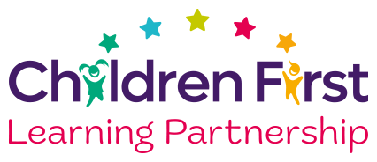


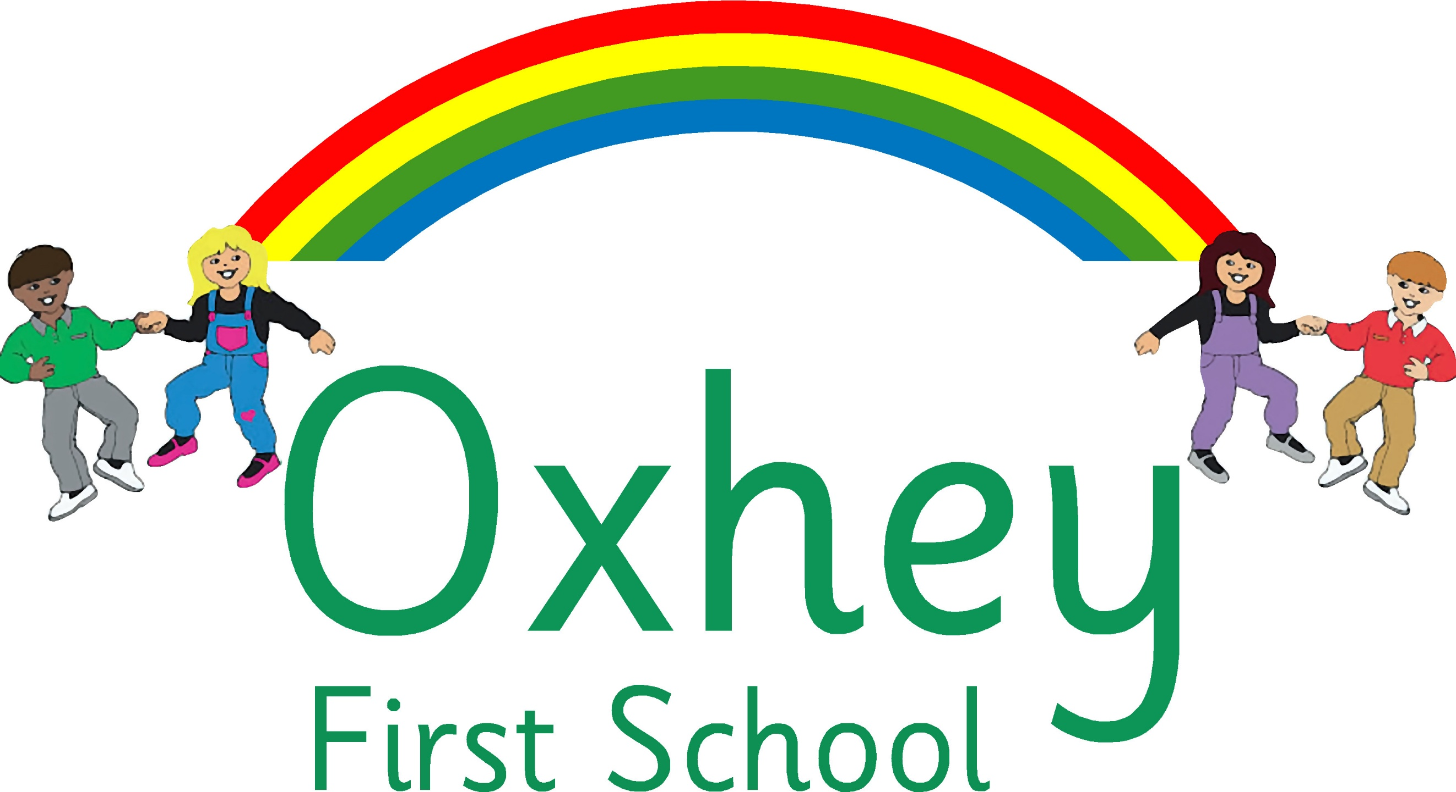
A Happy Place to Learn and Grow

Oxhey First School
Part of the Children First Learning Partnership

Mathematics Policy
September 2026

September 2028 or earlier if required
To be reviewed:
Agreed and ratified:
Head of School- Mrs. K Proffitt
September 2026

Responsible Officer:
Mrs W Parrott
Chair of Board:
The Mathematics Policy has been discussed and adopted by the Local Advisory Board in September 2026.

Children First Learning Partnership
Mathematics Policy 2026

At Oxhey First School, we provide rich and varied learning opportunities that allow all children to build knowledge and develop their skills and abilities to their full potential. Underpinning this are our eight core values of:
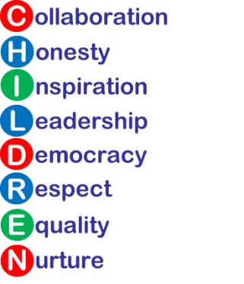

The overall intent of our school curriculum is to:
Recognise Uniqueness: in our pupils, staff, resources and whole school community.
Be Inclusive: recognising learning styles, learning needs at all levels and providing solutions to any barriers to learning we encounter.
Engage and Inspire: Through knowledge rich, highly enriched, progressive and purposeful contexts.
Promote Aspiration: offering challenge, accountability and responsibility for their learning.
Create Citizens of the Future: who thrive on responsibility, see difference as a strength of our community and use democracy to embed their own values and beliefs.
Our mathematics curriculum strives to drive all of these intentions and links very closely to the achievement and development of each one.
Intent
- To ensure the children have a sound understanding of all mathematical concepts, we use the CPAR approach (Concrete, Pictorial, Abstract and Reasoning). Children need to make links between practical equipment, pictures and abstract numbers because they learn in different ways. The CPAR approach helps children learn new ideas and build on their existing knowledge by introducing abstract concepts in a more familiar and tangible way.
- We build on this with rich connections across mathematical ideas to develop fluency, mathematical reasoning and competence in solving increasingly sophisticated problems.
- This ensures that across the Children First Learning Partnership we provide a high-quality mathematics curriculum that is both challenging and enjoyable for all, whilst expanding inquisitive and resilient minds.
- All children are exposed to their age-related expectations in a ‘keep up’ approach through the mastery format. Those children who are significantly working behind their year group expectations will be exposed to learning which at the appropriate level for them.

Implementation
A Unit of Work (Pathway)
Across the Children First Learning Partnership, a unit pathway enables all staff to have a clear understanding of how individual, sequenced components enables all children to have a clear composite understanding of each unit. Each unit will consist of:
- National Curriculum Programmes of Study are used for long term and medium term planning.
- White Rose Mathematics (WRM) small steps - this programme is used for long term, medium term, weekly and daily planning. Additional resources are used to support delivery of the mathematics curriculum e.g. Classroom Secrets, Grammarsaurus.
- To strengthen fluency, children in KS1 also take part in Mastering Number sessions.
- A mastery format is delivered where all children working at their age related expectations all start at the same point and then progress through the fluency and reasoning problems at their own pace.
- In all key stages, working walls reflect the unit of work that is being taught and demonstrate the build-up of skills throughout the unit incorporating the CPAR model and key vocabulary. Working walls are referred to regularly throughout lessons to encourage and promote independence.
- A wide range of mathematical vocabulary is taught, well-modelled and shared as part of the daily non-negotiables and used in context to demonstrate understanding.
- Teach: The C-P-A-R concrete, pictorial, abstract and reasoning approach is used to encourage children to make links between practical equipment, pictures and abstract numbers whilst learning new ideas and building on their existing knowledge to explore abstract concepts in a more familiar and tangible way.
- Application: Varied fluency, reasoning and problem solving are used to develop a deep and secure knowledge and understanding of mathematical concepts.
- Assess: Through live marking, formative and summative assessment (including end of unit and end of term) as well as through questioning, feedback and plenaries.
Calculation Policy
The calculation policy shows the methods we teach to solve addition, subtraction, multiplication and division problems and the progression across the school. Across the Children First Learning Partnership, children are taught a range of mental and pencil-and-paper methods, and encouraged to consider when different methods are appropriate and efficient.
A Lesson
Within each and every lesson, there are various sequential components which enables all children to progress no matter their ability. Below shows the sequenced order of a typical mathematics lesson across the Children First Learning Partnership.
- Daily counting / times tables - to promote automaticity with number facts.
- Daily starter through a flash back - used to revisit and retrieve previously taught skills, knowledge or concepts.
- Shared learning objective, steps to success and unit specific vocabulary - help to set the context for a lesson.
- Teaching exposition (I do) - a variety of strategies / small steps are used to model and explore new concepts.
- Sentence Stems - opportunities to discuss learning with a partner. Children are encouraged to speak in full sentences and reinforce vocabulary in context.
- Practise (We do) - opportunities to discuss learning with learning partners. Use of manipulatives – exploring the concrete, pictorial, abstract approach where necessary.
- Effective AfL(Assessment for Learning) is driven by frequent and precise questioning to assess progress, redirecting learning swiftly. (You do)
- Scaffolded learning activities linked to the learning objective using high quality resources and effective adult deployment to ensure all children achieve the learning outcome.
- Problem solving and reasoning – children are encouraged to explain and justify their thinking (independently and through guided sessions).
- Provide enough time for structured practice of foundational knowledge, particularly in EYFS and Key Stage 1.

Lessons are planned from the correct year groups ‘Programmes of Study’ from The National Curriculum. Teachers will be aware of the pre-units that need to be secure from previous year groups to ensure new content can be understood. The ‘Programmes of Study’ are then broken down into smaller steps to ensure lessons are driven by sharp learning objectives that are progressively linked.

Individual lessons are carefully planned using the most effective teaching materials so that pupils are given the best opportunities to show their understanding. Variation is consciously built in by teachers so that pupils can apply their learning to different contexts and make links.

Mathematical Language
Across the Children First Learning Partnership, we understand that mathematical language is crucial to children’s mathematical thinking. We introduce new words from the curriculum in a suitable context, with relevant real objects, mathematical apparatus, pictures and/or diagrams, explaining their meanings carefully. Key vocabulary used in a topic are displayed on the math’s working walls. In most lessons children work in pairs; discussing, explaining, disagreeing and proving math’s ideas, are integral to building understanding. Children work together so that through their dialogue they can develop a much stronger understanding.

All adults model the correct use of mathematical language and insist pupils do the same. Sentence stems are used to support children to speak about their work in full sentences using the correct terminology. Children understand and remember concepts far better when an answer is given within the context of a number sentence.

Manipulatives
A manipulative is a physical object that children or teachers can touch and move which is used to support the teaching and learning of mathematics. Through each year group, the children have the opportunity to use a range of resources to support their learning such as hundred squares, number lines, cubes, place value cards and other apparatus. In our lessons, Numicon, 5 frames, 10 frames, Hungarian 10 frames, Base10 equipment, Rekenrek, bead strings, place value counters and more are used regularly to support children to engage with mathematical ideas. Manipulatives are carefully selected to be the most appropriate and effective with a clear progression evident throughout the school.

Pitch, Pace and Challenge
Within the Children First Learning Partnership, the expectation is that the majority of children will move through the units at broadly the same pace. However, decisions about when to progress will always be based on the security of children’s understanding and their readiness to progress. Children who grasp concepts rapidly will be challenged through being offered rich and sophisticated problems. Those who are not sufficiently fluent with earlier material will consolidate their understanding, including additional practice, before moving on (pre-teach/ intervention).
Solving Problems
Across the Children First Learning Partnership, we teach a variety of problem-solving strategies which enable them to make sense of unfamiliar situations and tackle them intelligently.
Class teachers will seek opportunities for teaching problem solving strategies and more open-ended investigations that reinforce the unit of learning and encourage children to use their reasoning/ problem solving skills. Within this, children will be encouraged to predict, work systematically, justify, test their answers, record and identify patterns. All children will regularly access problem solving and reasoning activities linked to the unit of work.

A range of visual strategies are used to help children understand a problem. These are pictorial representations of problems or concepts that can be used for any of the operations: addition, subtraction, multiplication and division. In word problems, these strategies have a huge benefit in helping children decide which operations to use or visualise problems.
Bar Modelling is also used to help children understand a problem. Bar models are pictorial representations of problems or concepts that can be used for any of the operations: addition, subtraction, multiplication or division. In word problems, bar models hold the huge benefit of helping children decide which operations to use.
While working on a problem, children are encouraged to use their metacognition to ask questions like, ‘What am I trying to work out?’, ‘How am I going about it?’, ‘Is the approach that I’m taking working?’, and ‘What other approaches could I try?’ When the problem is completed, encourage children to ask questions like, ‘What worked well when solving this problem?’, ‘What didn’t work well?’, ‘What other problems could be solved by a similar approach?’, and ‘What similar problems to this one have I solved in the past?’ Children should communicate their thinking verbally and in writing—using representations, expressions, and equations - to both teachers and other children. Our children are constantly challenged to explain why, proving how they know convincing others that they are correct as well as finding all possible answers. Pupils are encouraged to develop a ‘have a go’ attitude and are comfortable with making mistakes, as they are seen as part of the learning process.

Mathematical Knowledge
Quick and automatic retrieval of number facts is important for success in mathematics. It is likely that children who have problems retrieving addition, subtraction, multiplication, and division facts, including number bonds and multiples, will have difficulty understanding and using mathematical concepts they encounter later on in their learning journey. Across the Children First Learning Partnership, we ensure that children are given ample opportunities to develop fluent recall and automaticity of number facts. Mental/oral starters and warm-ups are used at the start of lessons in a variety of ways to ensure prior learning is revisited and reinforced. In the Early Years and Key Stage One, the children also take part in daily counting. In Key Stage Two, times tables and number facts are taught daily to develop fluency and automaticity.

Impact
What we aim to achieve from our mathematics curriculum across the Children’s First Learning Partnership:

- ‘Mastery’ is something we want all children to achieve and involves utilising a range of strategies to help children develop a deep and secure knowledge and understanding of mathematics.
- All staff model positive attitudes towards mathematics and a belief that all pupils can succeed.
- An enjoyment of and a curiosity about mathematics and for children to feel confident to become successful;
- Children’s abilities to use and apply mathematics to solve problems in both the classroom and in ‘real life’ contexts;
- A confidence to communicate ideas in written form and orally;
- Independent and collaborative ways of working, encouraging children to share ideas and solve problems together;
- A wide range of mathematical vocabulary to be modelled and used in the classroom;
- The children’s ability to recall mental facts accurately and quickly and using effective written calculation methods;
- Children’s logical thinking, reasoning and ability to problem solve as transferable life skills.
Assessment
Our impact will be measured by using both formative and summative assessment.
Formative
Assessment is continuous and provides teachers with up-to-date and accurate information about the specifics of what children do and do not know. This information allows teachers to adapt their teaching so it builds on children’s existing knowledge, addresses their weaknesses, and focuses on the next steps that they need in order to make progress.
From the beginning of every lesson, teachers and teaching assistants will be assessing what their children are, or are not understanding and use this to scaffold each segment of the lesson. Interventions will be both planned for and ‘live’, meaning that misconceptions are dealt with immediately and high attaining children are challenged appropriately. We pride ourselves in our use of continuous AFL to identify and direct children’s next steps in learning. Our staff are highly skilled to provide a personalised and flexible curriculum for individual children that may need reasonable adjustments to the curriculum. These adaptations increase access to the lesson content enabling them to reach their full potential.
Teachers will be constantly assessing against the National Curriculum statements to ensure that children are meeting requirements. As part of our assessment and to support teacher’s judgements, children in Years 1 to 4 undertake a termly formal assessment, which assesses the concepts that have been taught. White Rose ‘End of Unit’ checks will be used to support teachers in their judgements and to ensure that planning and intervention can be adapted accordingly. End of term assessments will be used to assess whether children have retained and applied their learning effectively with progress and attainment recorded on our internal tracking system. This is then converted and analysed through scaled scores which are evaluated termly by the subject leaders. Termly in-house moderations will be carried out to ensure that teacher’s judgments and assessments are accurate and consistent throughout the school. Teacher assessment judgments in mathematics will be shared with parents on a termly basis and on their annual report.
Effective marking and feedback are an important element of teachers’ responses to children’s learning. (See Feedback, Marking and Presentation Policy for further detail and information.)
Statutory Assessments
Children in Year 4 access the Year 4 Multiplication Tables Check (MTC) which is administered during the June testing window each year. It is a statutory assessment for all Year 4 pupils in England and assesses pupils' rapid recall of multiplication facts. This is an online test where children are exposed to 25 multiplication questions from the 2 times table up to the 12 times table. For each question children have 6 seconds to answer.
Role of Leaders
- Plan an effective and varied schedule of monitoring including moderations, which is triangulated through our school leaders and triad moderation so that we know the Quality of Education in mathematics is implemented and embedded throughout the school.
- Respond quickly and supportively to all barriers preventing outstanding implementation and impact in mathematics.
- Support staff to identify potential barriers and plan effective and quantifiable interventions.
- Use assessment information to provide effective CPD and challenge.
- Provide clear updates to the Local Advisory Board, Headteacher and SLT.
Version Control

Version | Review Date | Changes Made
V2 | 14.01.2022 | CPAR approach (Concrete, Pictorial, Abstract and Reasoning).
V2 | 14.01.2022 | Change the the order of ‘a lesson’ with the addition of daily counting / times tables, the rearranging of the AFL being moved to after the practise, Differentiated changed to scaffolding and with the addition of (independent and through guided sessions) on the problem solving and reasoning
V2 | 14.01.2022 | Through the document ‘At Children First Learning Partnership change to Across the Children First Learning Partnership
V2 | 14.01.2022 | Within ‘solving problems’ - RUCSAC is an acronym displayed in every KS2 classroom and discussed with children within KS1 to help children remember how to tackle mathematical word problems. Read, Understand/ Underline, Choose, Solve, Answer, Check. You can help children to understand this further with these simple explanations:
V2 | 14.01.2022 | Within ‘mathematical knowledge’ – the addition to automaticity of number facts
V2 | 14.01.2022 | Within ‘Assessment’ – the wording ladders has been exchanged with trackers
V2 | 14.01.2022 | Within ‘Assessment’ - Effective marking and feedback are an important element of teachers’ responses to children’s learning. This may be given either orally during live marking or during a marking conference.
V3 | 12.1.23 | Within ‘Intent’ – addition of All children are exposed to their age related expectations in a keep up approach through the mastery format. Those children who are significantly working behind their year group expectations will be exposed to learning which at the appropriate level for them
V3 | 12.1.23 | Within ‘ A lesson’ – each bullet point has been expanded to explain what this means.
V3 | 12.1.23 | Within ‘A lesson’ – The addition of A mastery format is delivered where all children working at their age related expectations all start at the same point and then progress through the fluency and reasoning problems at their own pace.
V3 | 12.1.23 | Within ‘A lesson’ – The addition of the wording small steps within the Teaching Exposition bullet point.
V3 | 12.1.23 | Within ‘Pitch, Pace and Challenge’ – the removal of ‘before being moved on’
V3 | 12.1.23 | Within ‘Assessment’ – in ‘Formative’ the addition of continuous has been added within the ‘ We pride ourselves in our use of continuous AFL.’
V3 | 12.1.23 | Within ‘Mathematical Knowledge’ – in ‘impact’ the addition of Mastery’ is something we want all children to achieve and involves utilising a range of strategies to help children develop a deep and secure knowledge and understanding of mathematics.
V3 | 12.1.23 | Within ‘Role of Leaders’ – the addition of Support staff to identify potential barriers and plan effective and quantifiable interventions.
V4 | 9.1.24 | Within ‘Assessment’ marking conferences has been removed.
V4 | 9.1.24 | Added for all in intent
V4 | 9.1.24 | In a unit of work (pathway) Pre Unit A has been added to prior learning and (prior learning A and end of unit assessments B) in assessment
V4 | 9.1.24 | In ‘a lesson’ (I do), (We do) and (You do) has been added
V4 | 9.1.24 | In ‘Solving Problems’ bar models has been replaced with a variety of strategies and metacognition has been added into the question paragraph
V4 | 9.1.24 | In ‘Role of the Leaders’ including moderations, which is triangulated through our school leader and triad moderation has been added.
V5 | 3.10.25 | - Prior Learning- this is achieved through targeted questioning and on going assessment through daily lessons.
V5 | 3.10.25 | - Assess- through live marking, formative and summative assessment (end of unit assessments) as well as through questioning, feedback and plenaries.
V5 | 3.10.25 | - Practise (We do)- Opportunities to discuss learning with learning partners - Children are encouraged to speak in full sentences and reinforce vocabulary in context. Use of manipulatives – exploring the concrete, pictorial, abstract approach where necessary.
V5 | 3.10.25 | - Within the Children First Learning Partnership, the expectation is that the majority of children will move through the topics at broadly the same pace.
V5 | 3.10.25 | - . In our lessons numicon, cuisenaire rods and dienes blocks (and many more) are used regularly to support children to engage with mathematical ideas
V5 | 3.10.25 | - Class teachers will seek opportunities for teaching problem solving strategies and more open ended investigations that reinforce the unit of learning and encourage children to use their reasoning/ problem solving skills.
V5 | 3.10.25 | - Within the Children First Learning Partnership, assessment in Mathematics is continuous
V5 | 3.10.25 | - This is given orally during live marking and is always:
V5 | 3.10.25 | Statutory Assessments  All children in year 4 access the year 4 Multiplication Check, which takes place in June every year. This is an online test where children are exposed to 25 multiplication questions from the 2 times table up to the 12 times table. For each question children have 6 seconds to answer.
V5 | 3.10.25 | The RUCSAC strategy for problem solving has been removed from the policy.
V6 | 29.09.26 | Implementation:  - To strengthen fluency, children in Key Stage 1 also take part in Mastering Number sessions.  - Additional resources are used to support delivery of the mathematics curriculum e.g Classroom Secrets, Grammarsaurus, Primary Stars Mathematics  - In all Key Stages, working walls reflect the unit of work that…  - A wide range of mathematical vocabulary is taught, well-modelled and shared as part of the daily non-negotiables…  - Assess- through live marking, formative and summative assessment (including end of unit and end of term)
V6 | 29.09.26 | A Lesson:  - Success criteria has been replaced with Steps to Success  - …previously taught skills, knowledge or concepts.  - Provide enough time for structured practice of foundational knowledge, particularly in EYFS and Key Stage 1  - …using high quality resources and effective adult deployment
V6 | 29.09.26 | Manipulatives:  Rekenrek has been added. Dienes has been replaced by Base10 equipment.
V6 | 29.09.26 | Pitch, Pace and Challenge:  Topics has been replaced with ‘units’
V6 | 29.09.26 | Solving Problems:  Bar Modelling section added.
V6 | 29.09.26 | Mathematical Knowledge:  - Lessons has been replaced by ‘learning journey’  - Oral/warm ups has been added to mental starters.
V6 | 29.09.26 | Impact:  An enjoyment of and a curiosity about…
V6 | 29.09.26 | Assessment:  Assessment is continuous and provides teachers with up-to-date…  Reference to Marking, Feedback and Presentation Policy has been added.  Added section beginning, Teachers will be constantly…

